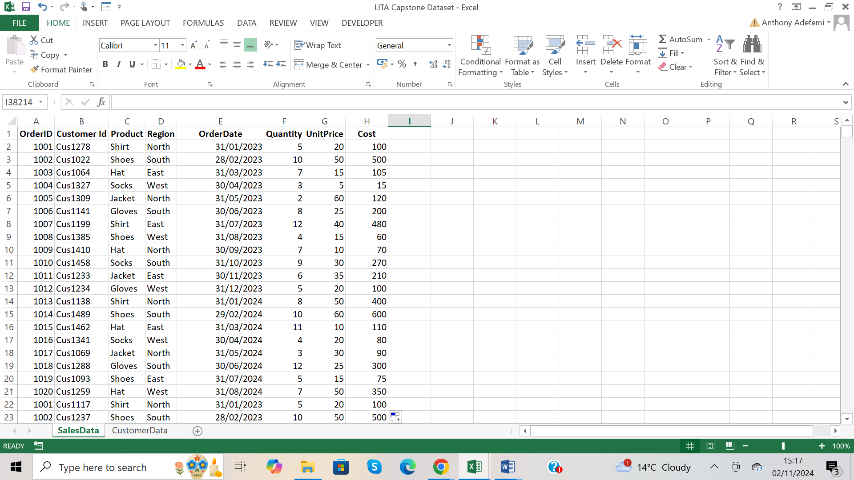

Added a new column called Cost. I calculated cost by =F2\*G2 on the first column. Then I selected the first column, then double clicked the auto-fill handle.

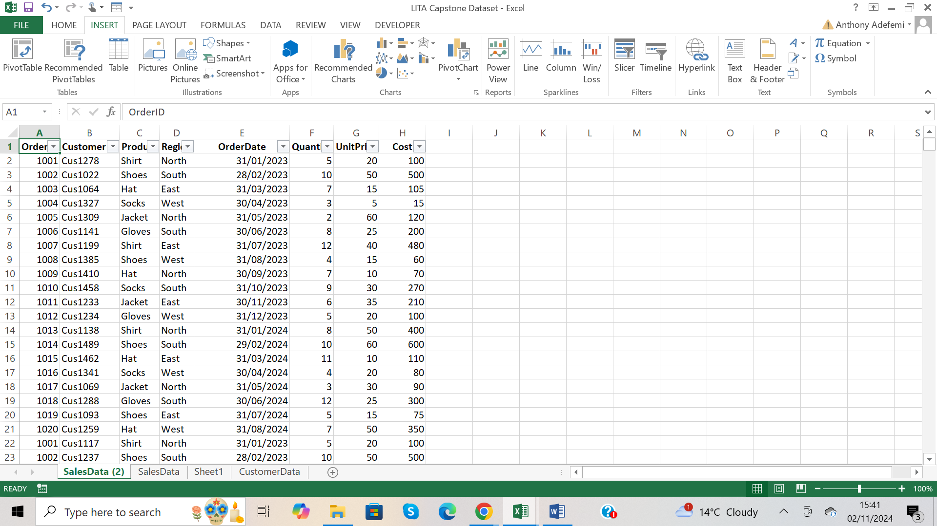

Pressed Ctrl + Shift + L to apply filter button to see the options

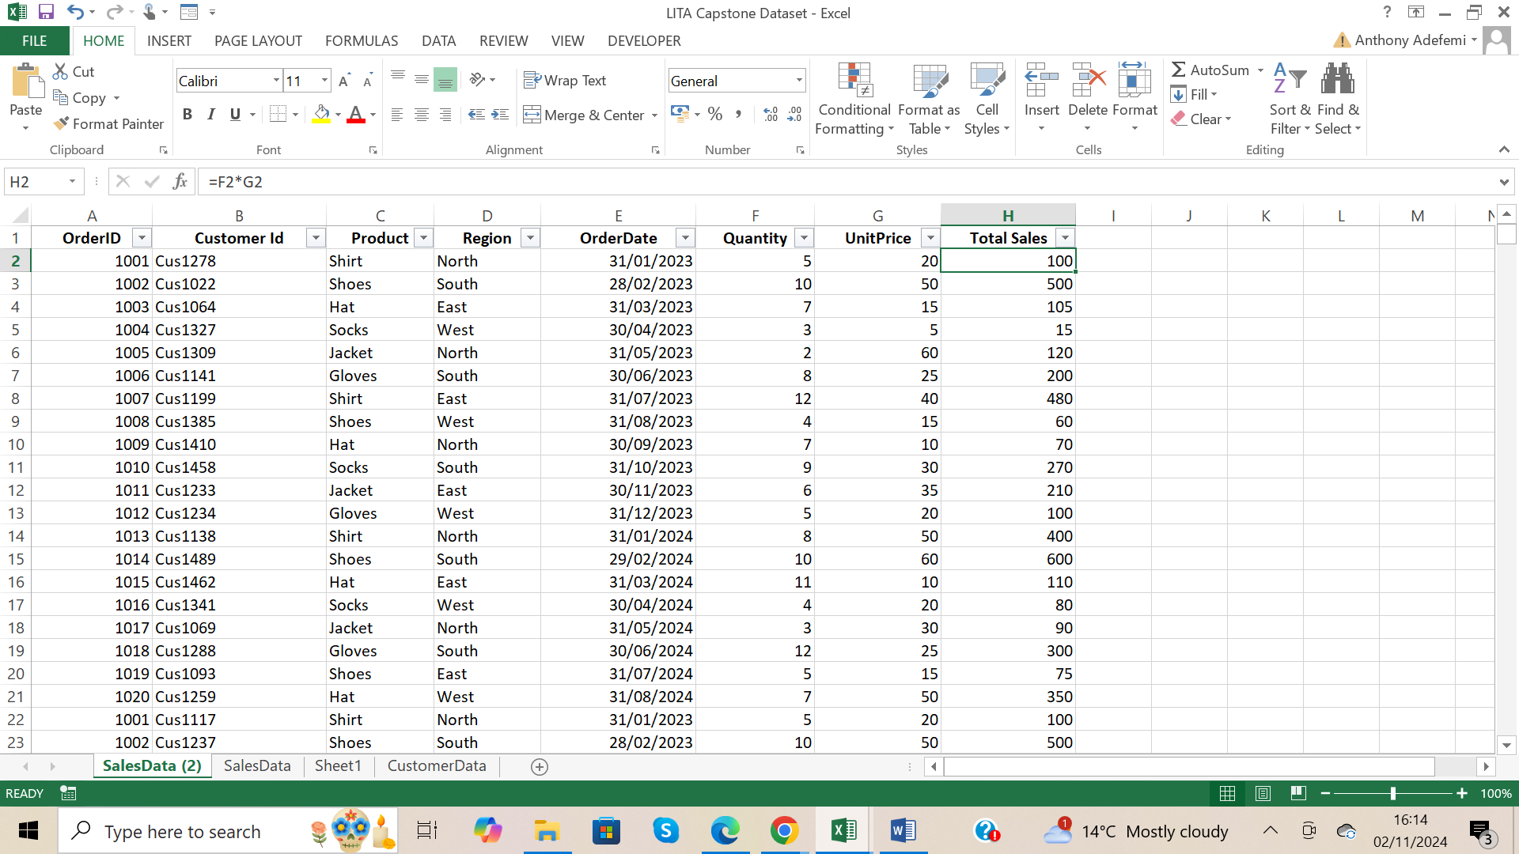

Renamed Column Cost to Total Sales, and expanded the width of each column so each column name can be properly shown.

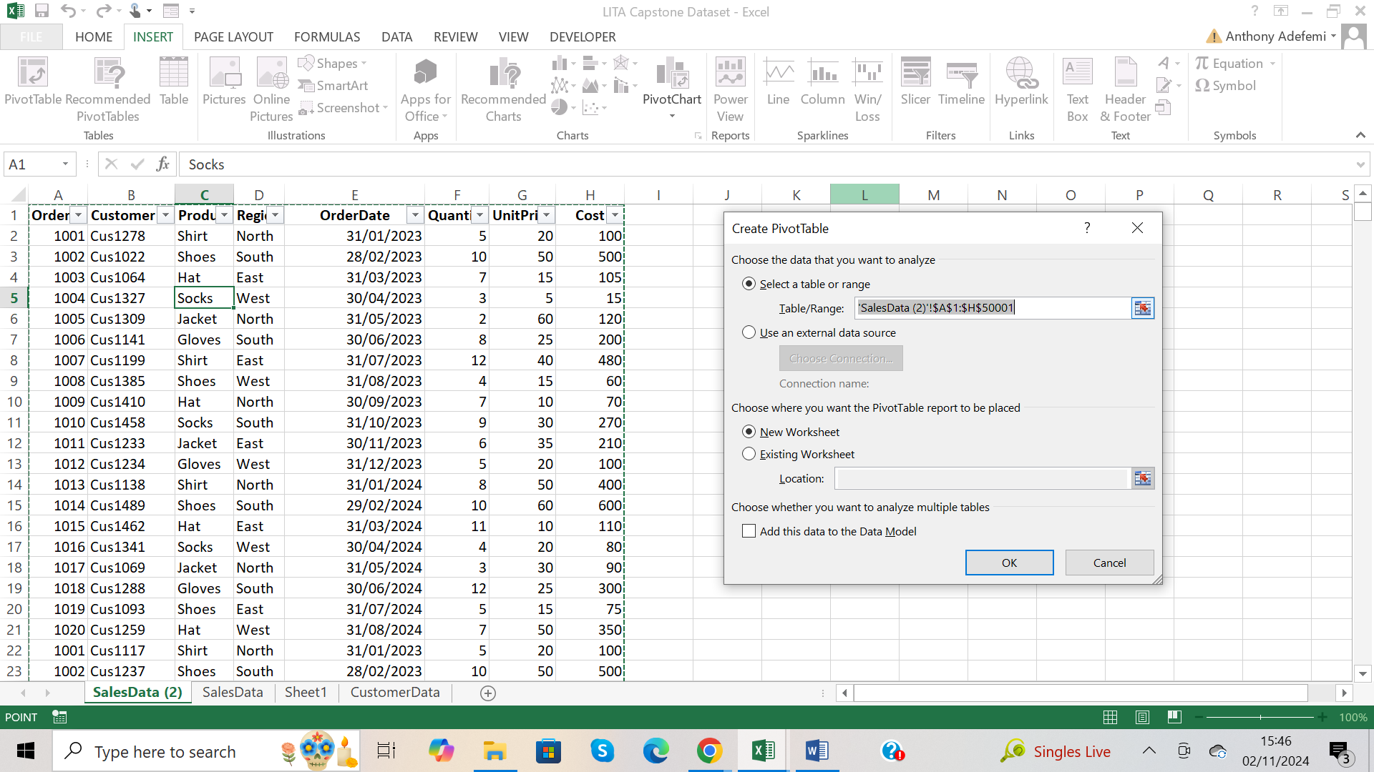

Dialog box when I clicked on PivotTable

Dialog box when I clicked on PivotTable



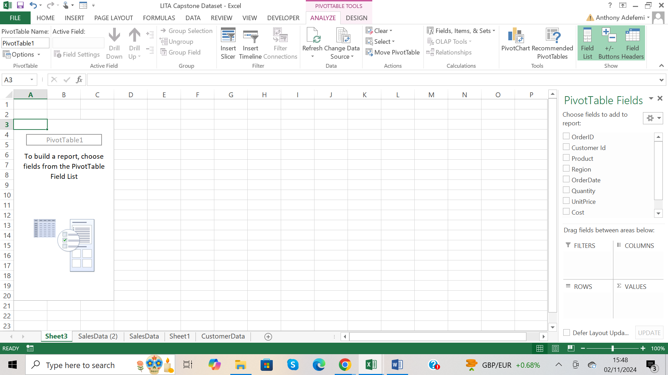

A Pivot Table place holder came up

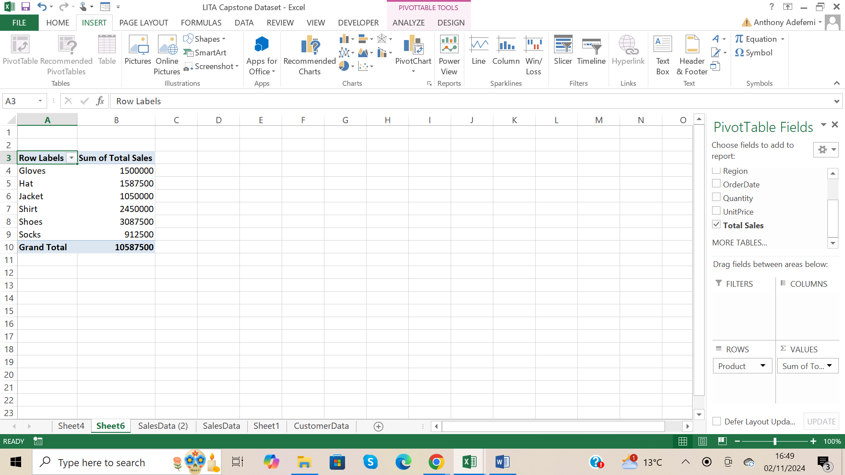

Placed Product in rows bucket, and Total Sales in Values bucket.

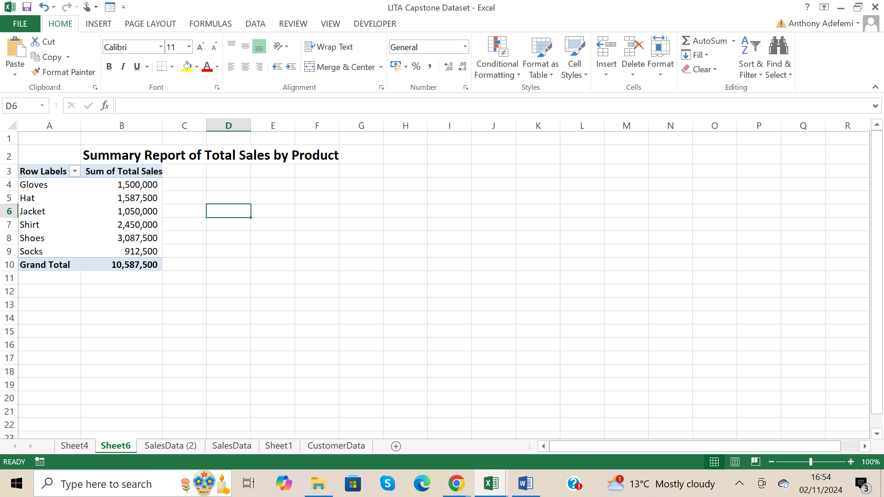

Pivot Table Summary Report of Total Sales by Product.

From The Report, the product with the highest number of sales is Shoes, the product with the lowest sales is socks.

I highlighted the Sum of Total Sales column and pressed Ctrl + Shift +1 to format comma separated, so the numbers can be readable, and removed two decimal places.

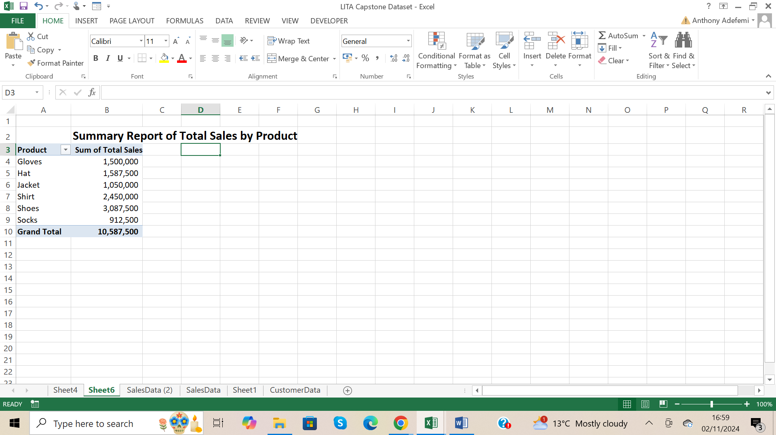

Renamed Row labels header to Product, and put a title for the Report



A Pivot Table place holder came up

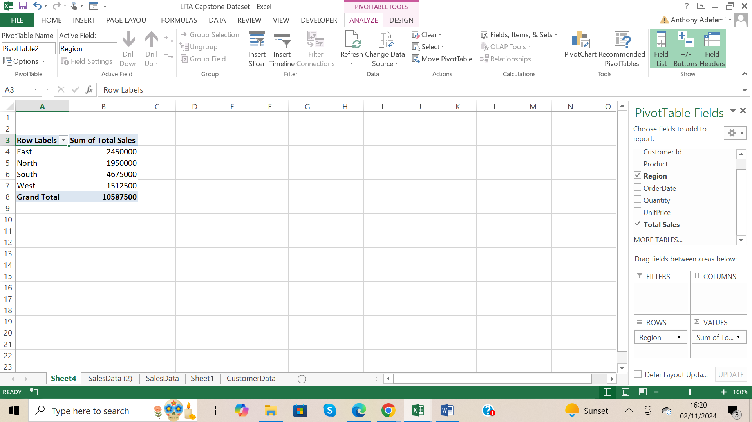

I placed the Region in the Rows bucket, and the Total Sales in the Values bucket.

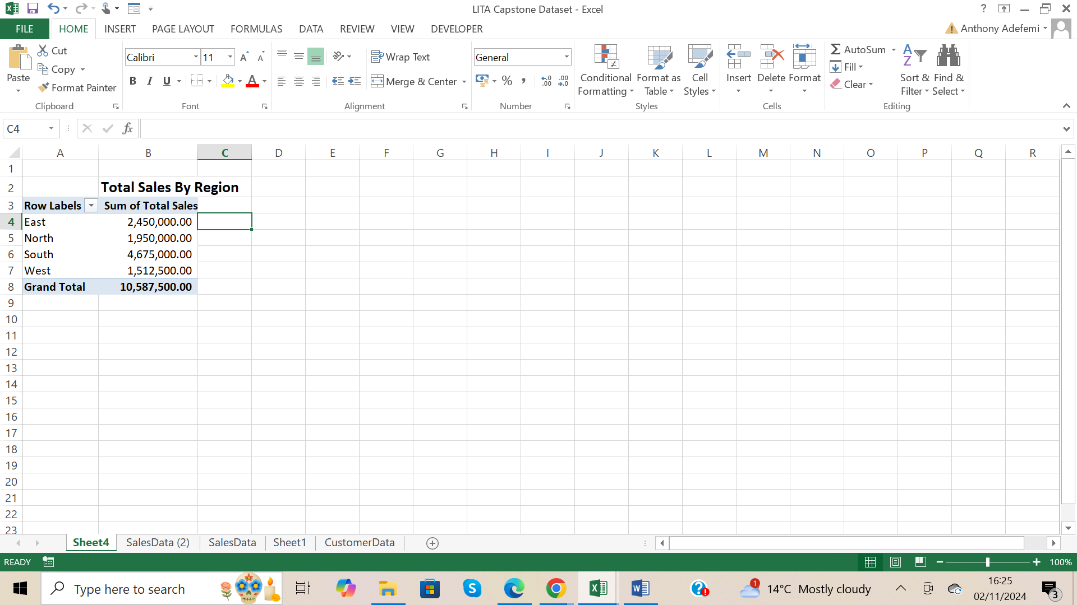

I highlighted the Sum of Total Sales column and pressed Ctrl + Shift +1 to format comma separated, so the numbers can be readable.

This Pivot Table Report shows the total sales made.

It also shows how much was made in each of the Regions.

From the Pivot Table the highest sales was in the South region, and the lowest sales was in the West Region.

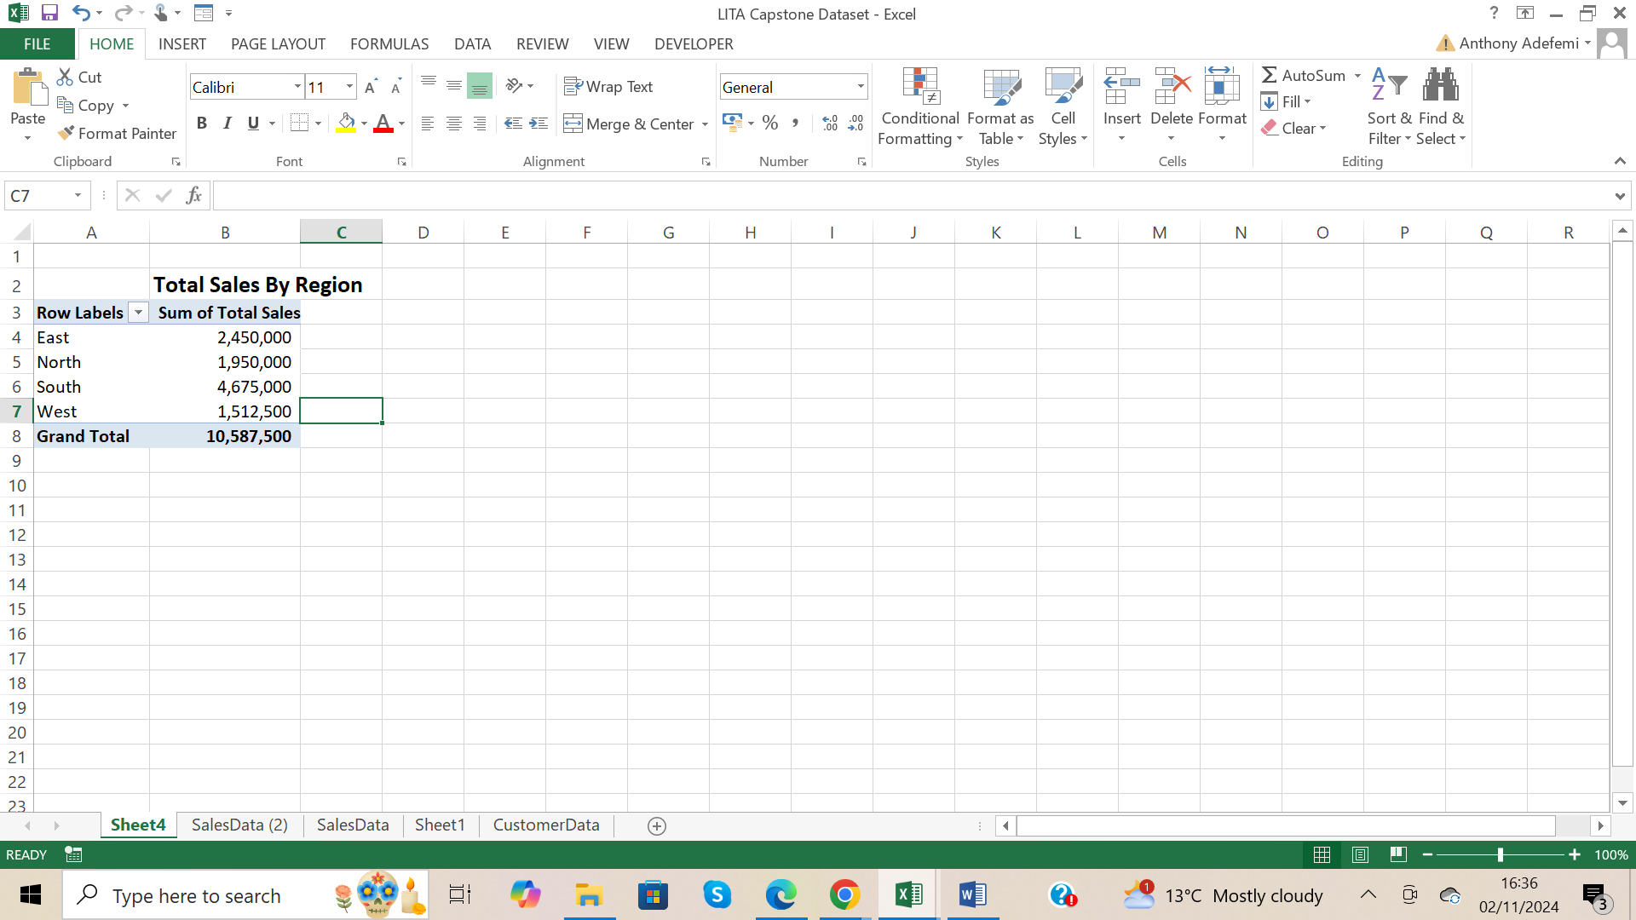

Removed two decimal points from Sum of Total Sales column.

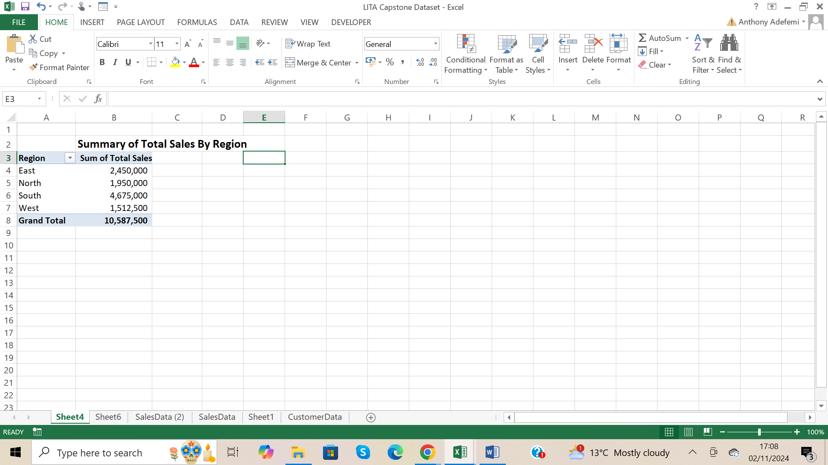

Renamed Row labels header as Region, and typed a title for the Report as Summary of Total Sales by Region.

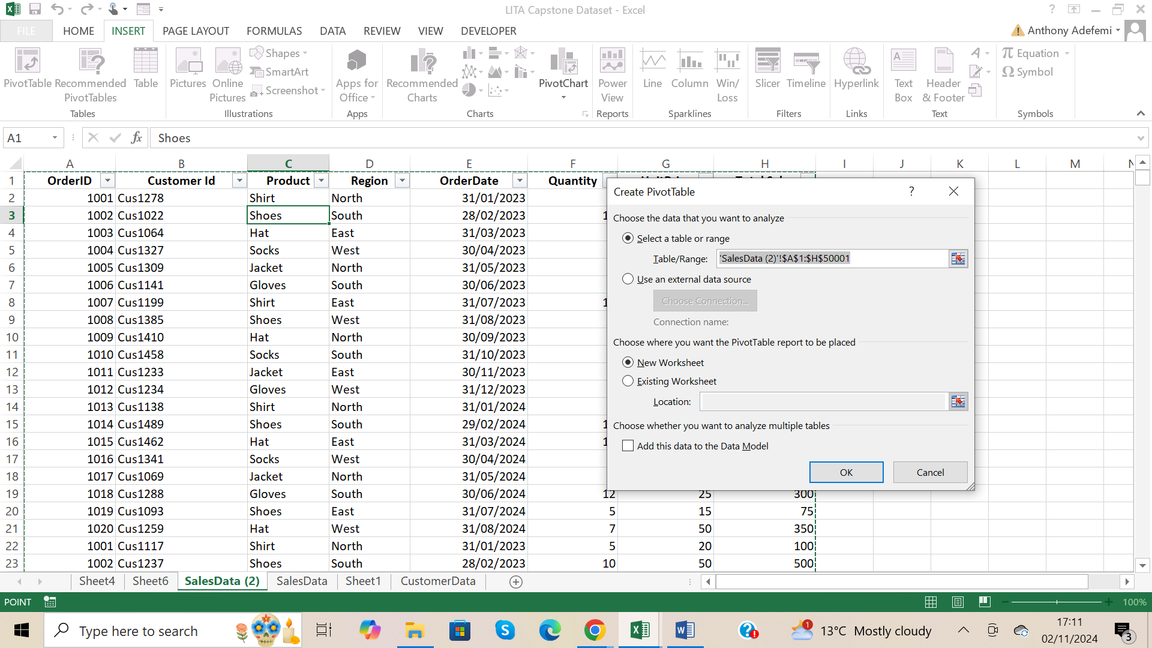

Dialog box when I clicked on PivotTable

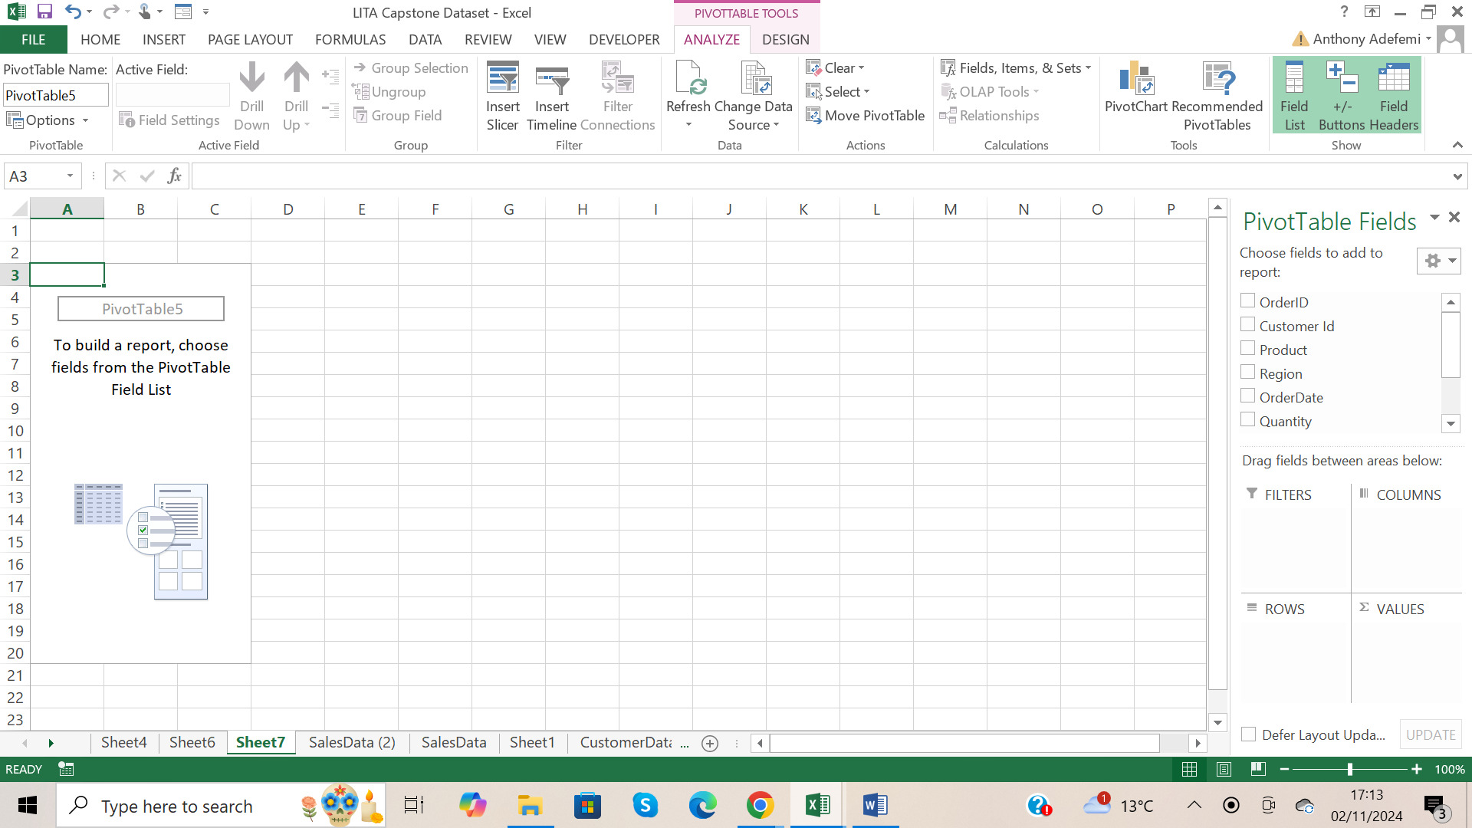

A Pivot Table place holder came up

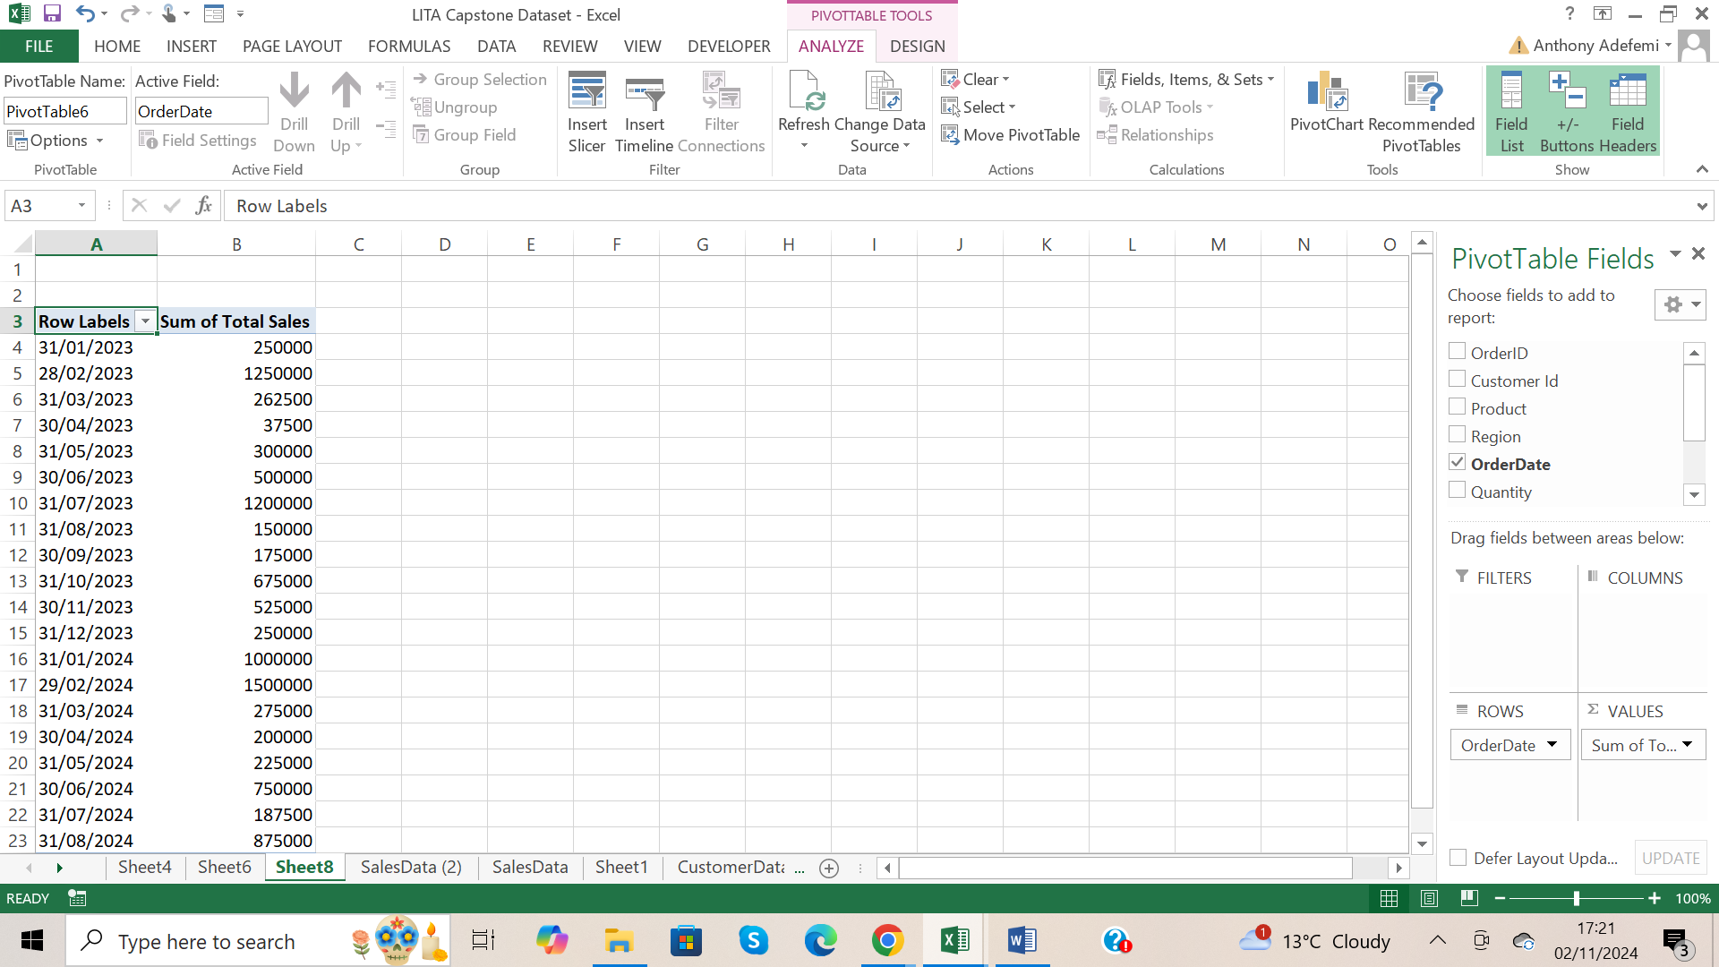

Order date went to rows bucket and Total Sales when to values bucket.

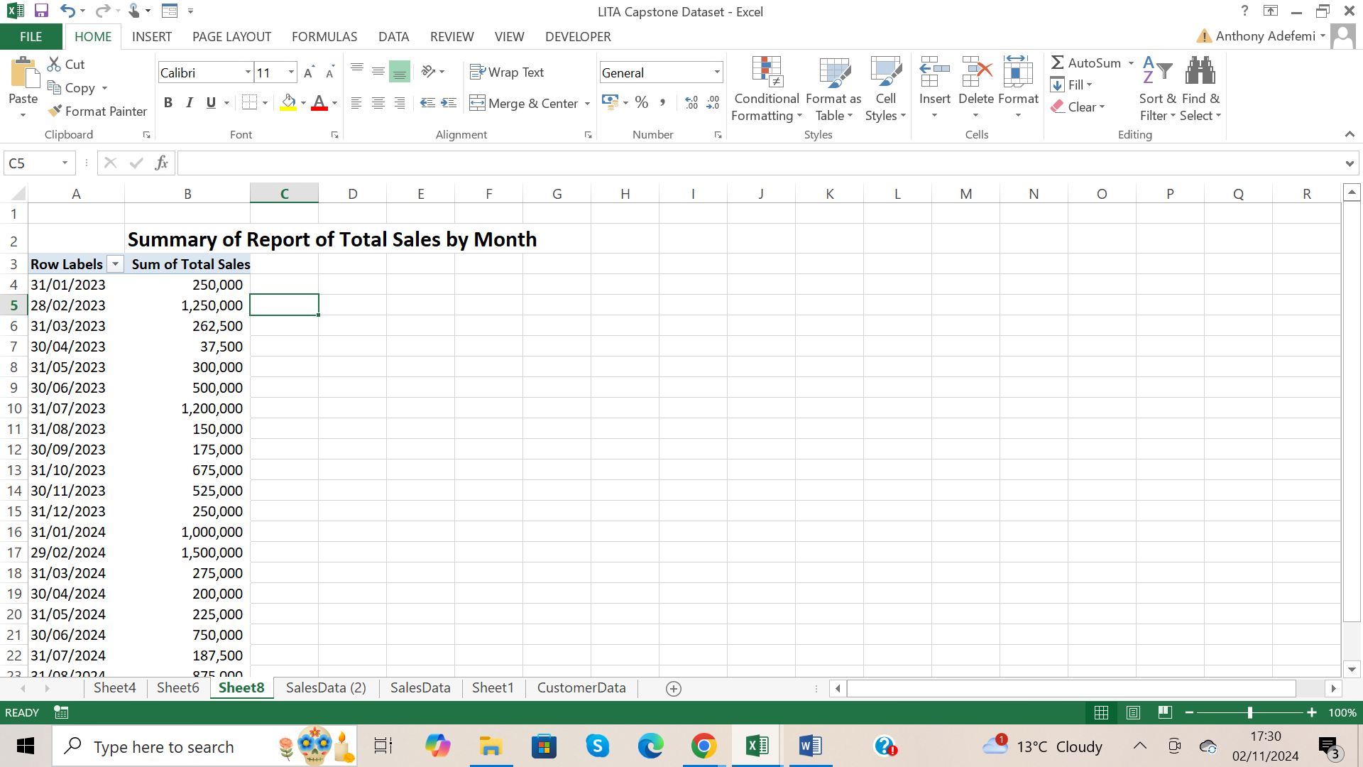

I highlighted the Sum of Total Sales column and pressed Ctrl + Shift +1 to format comma separated, so the numbers can be readable, removed the two decimal places on Sum of Total Sales column.

Typed a title for the Pivot Table report as Summary of Report of Total Sales by Month

From the Report the highest sale was made on 29/02/2024.

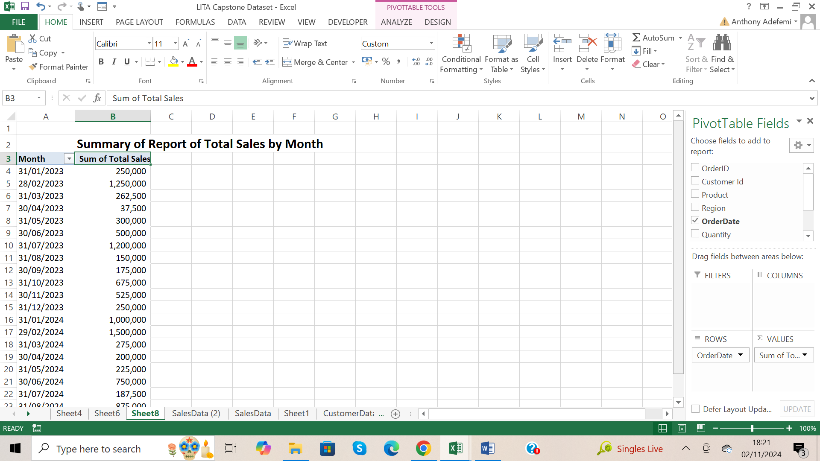

Renamed Row Labels header to Month

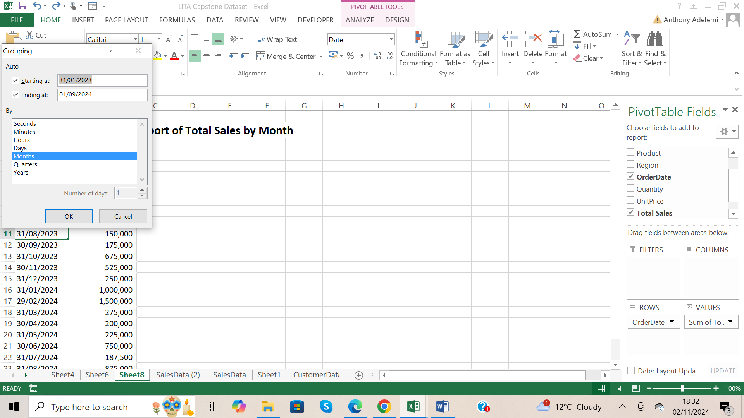

Did a right click on the month column, clicked on group, then grouped my month

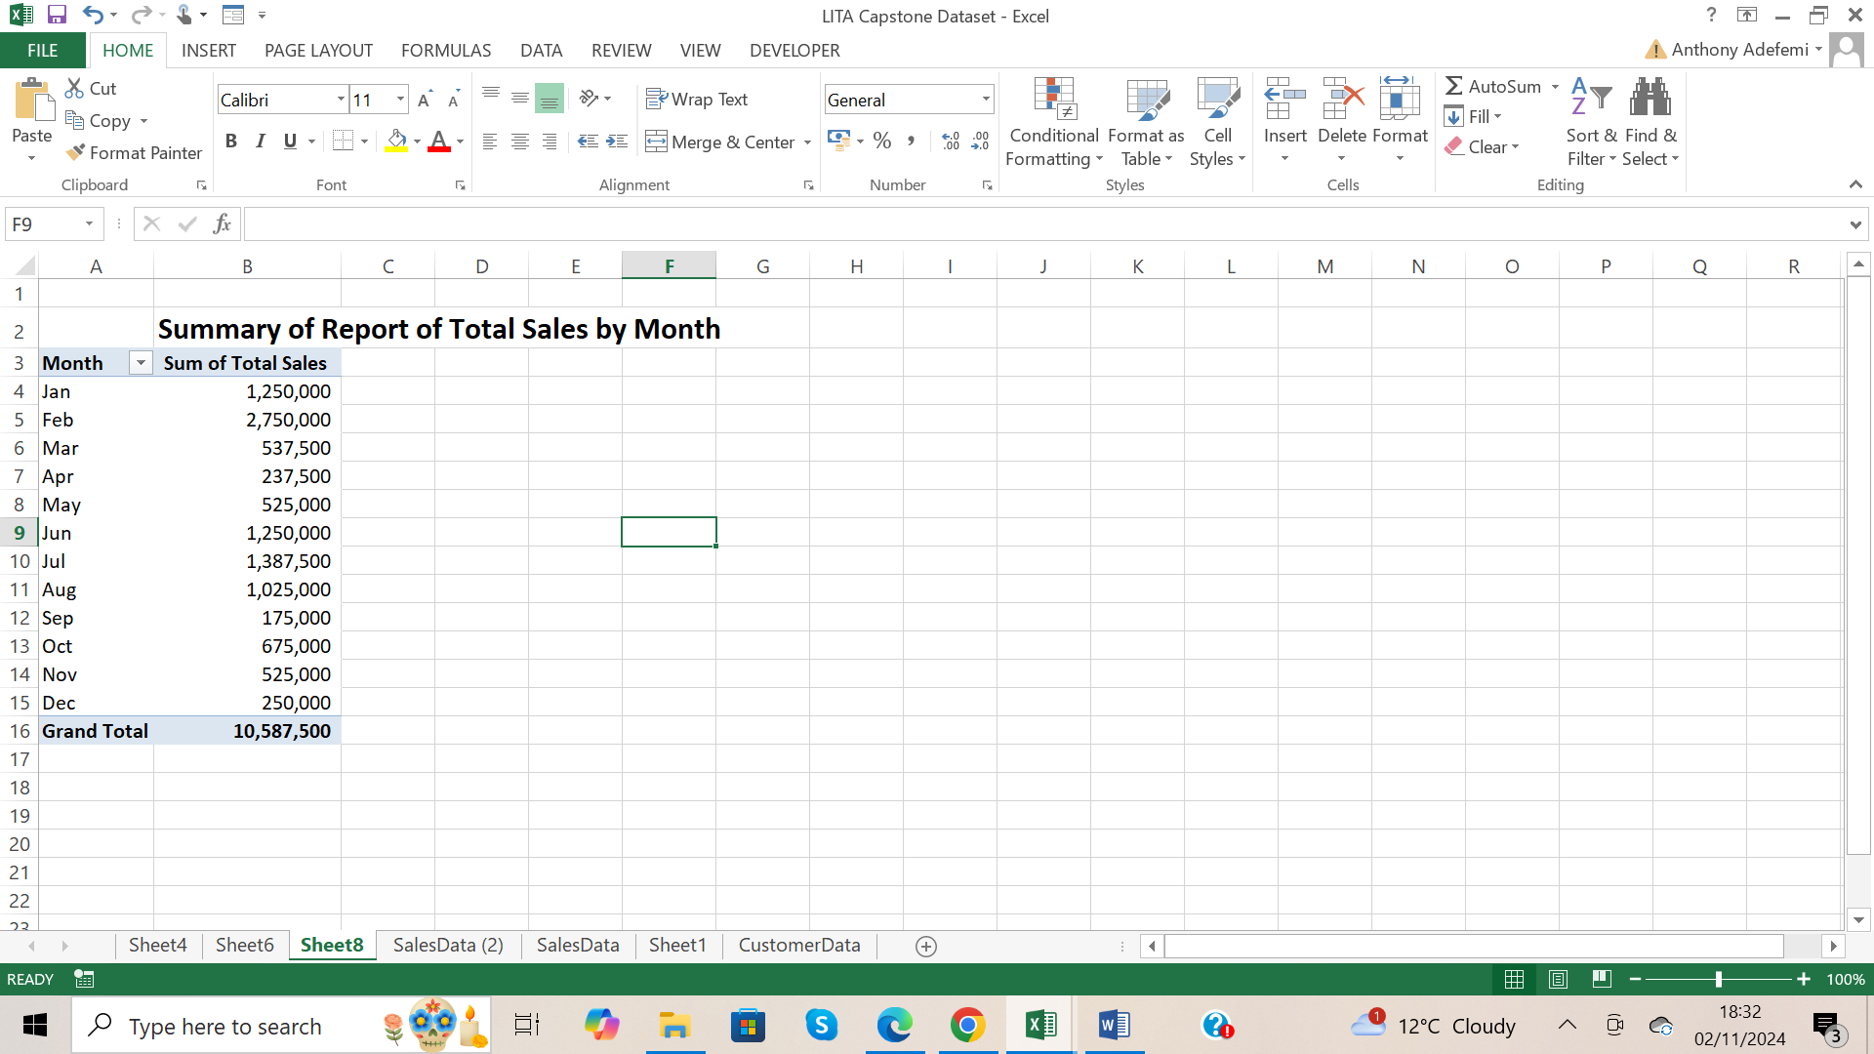

From the Report the highest sale was in the month of February, and the lowest sale was in the month of September.

Average sales by product

I sorted the Product Column from A to Z

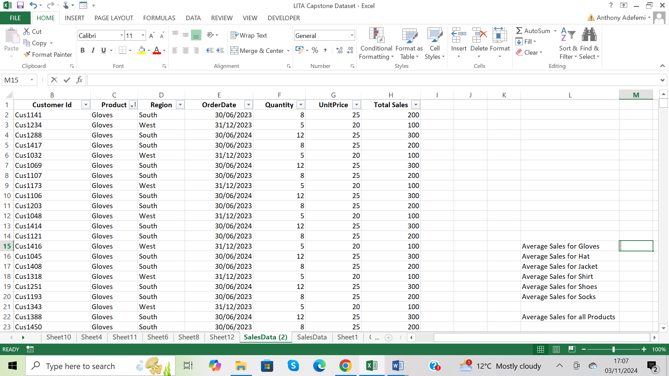

Average Sales for gloves

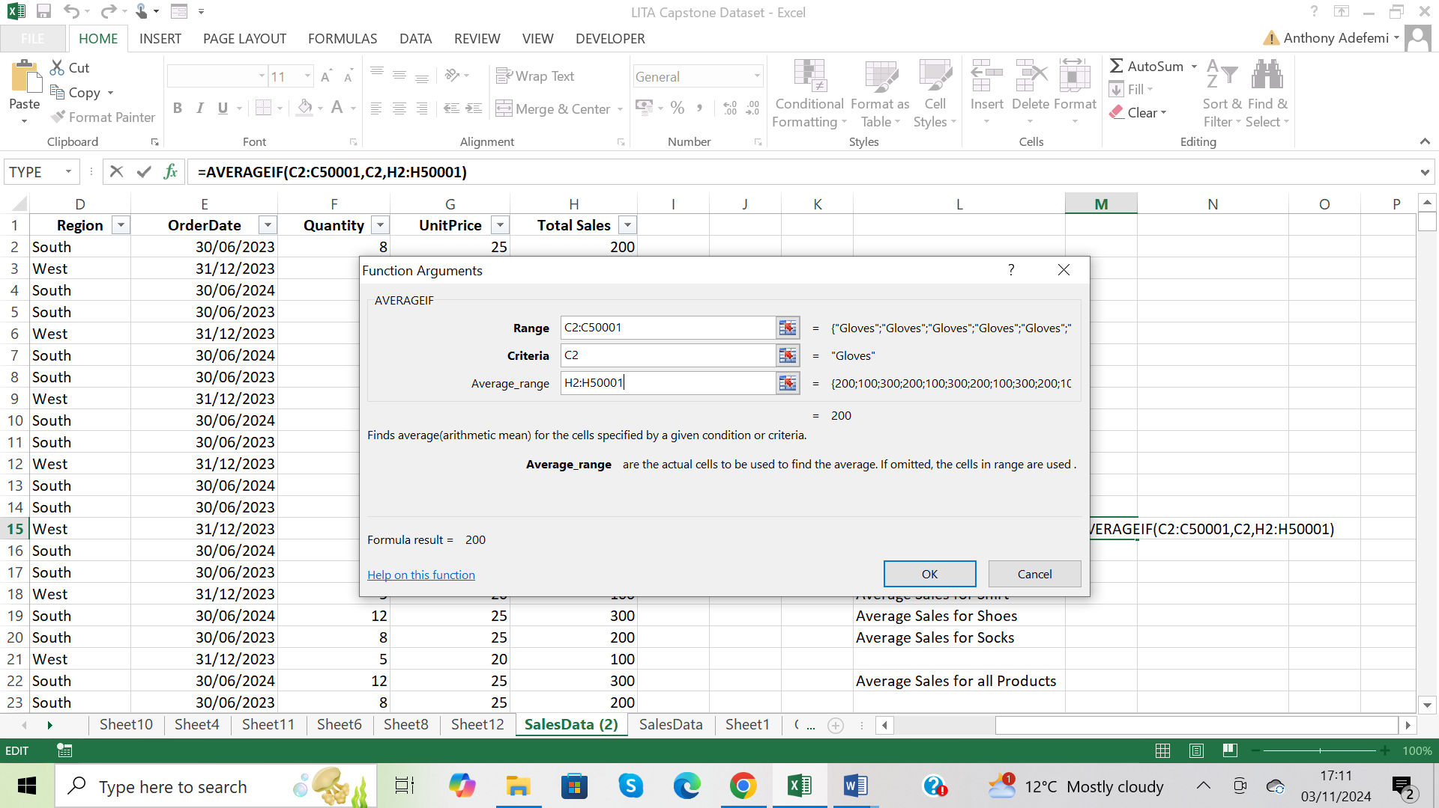

=AVERAGEIF then Ctrl A to open the function arguments dialogue box, enter the values, click ok

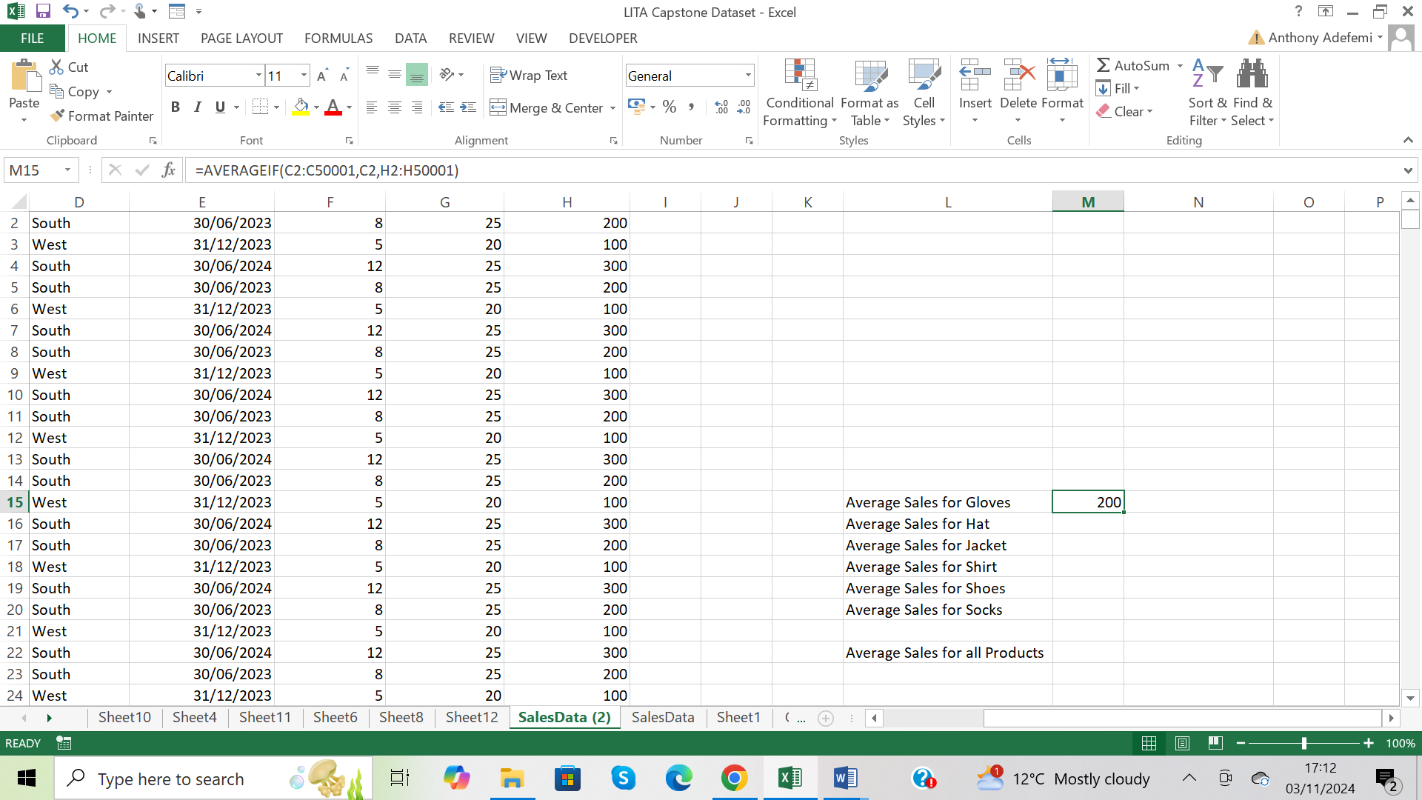

Average Sales for gloves is 200

Average Sales for Hat

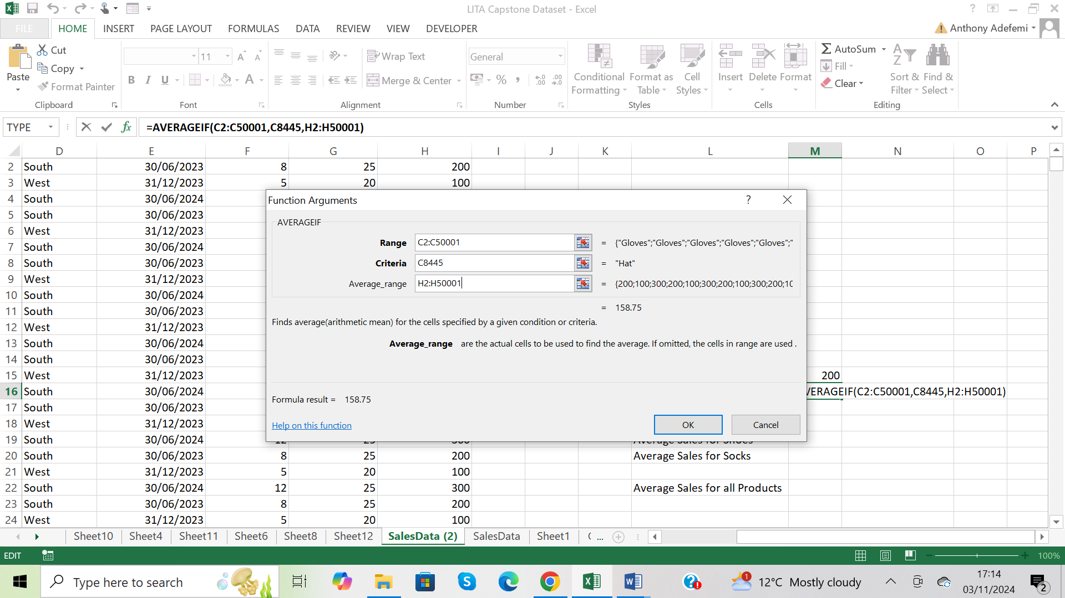

=AVERAGEIF then Ctrl A to open the function arguments dialogue box, enter the values, click ok

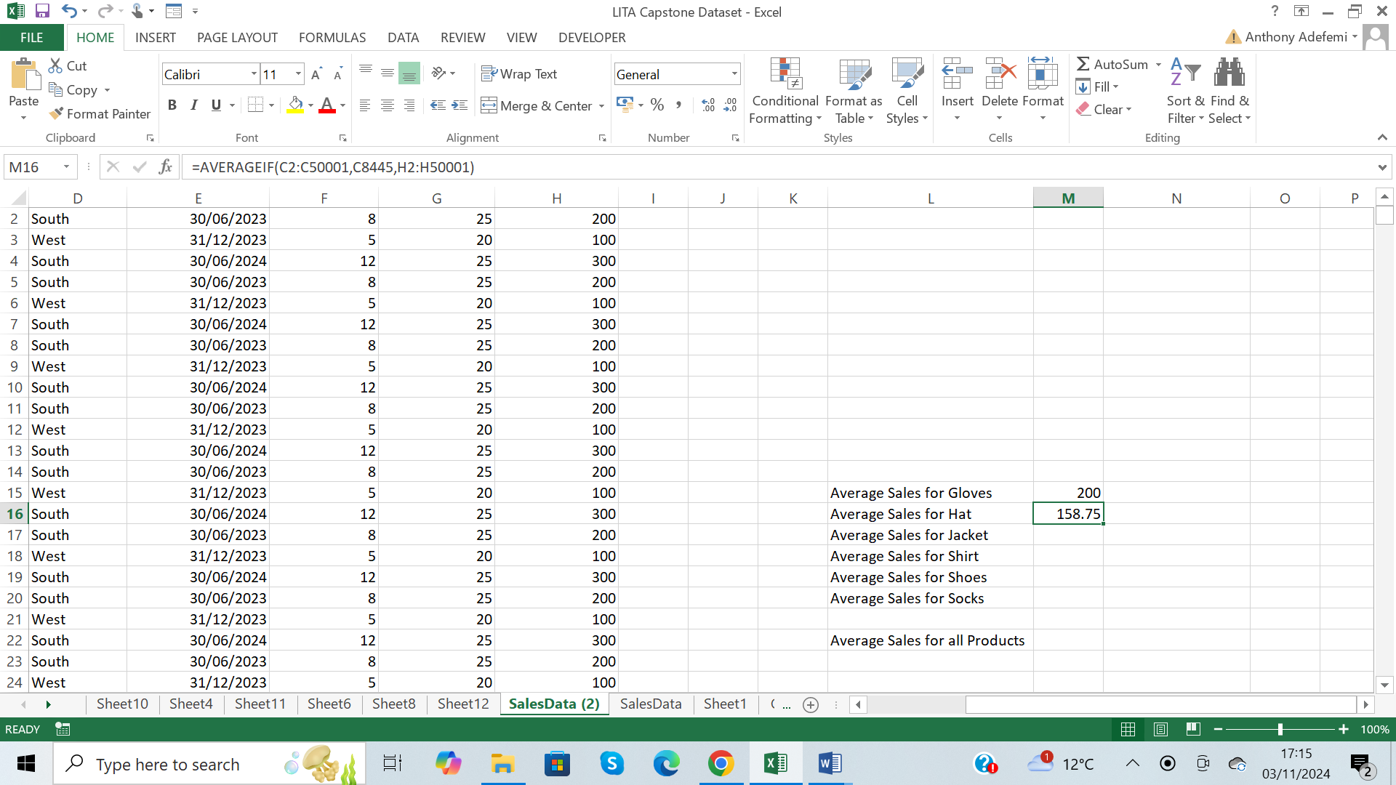

Average Sales for hat is 158.75

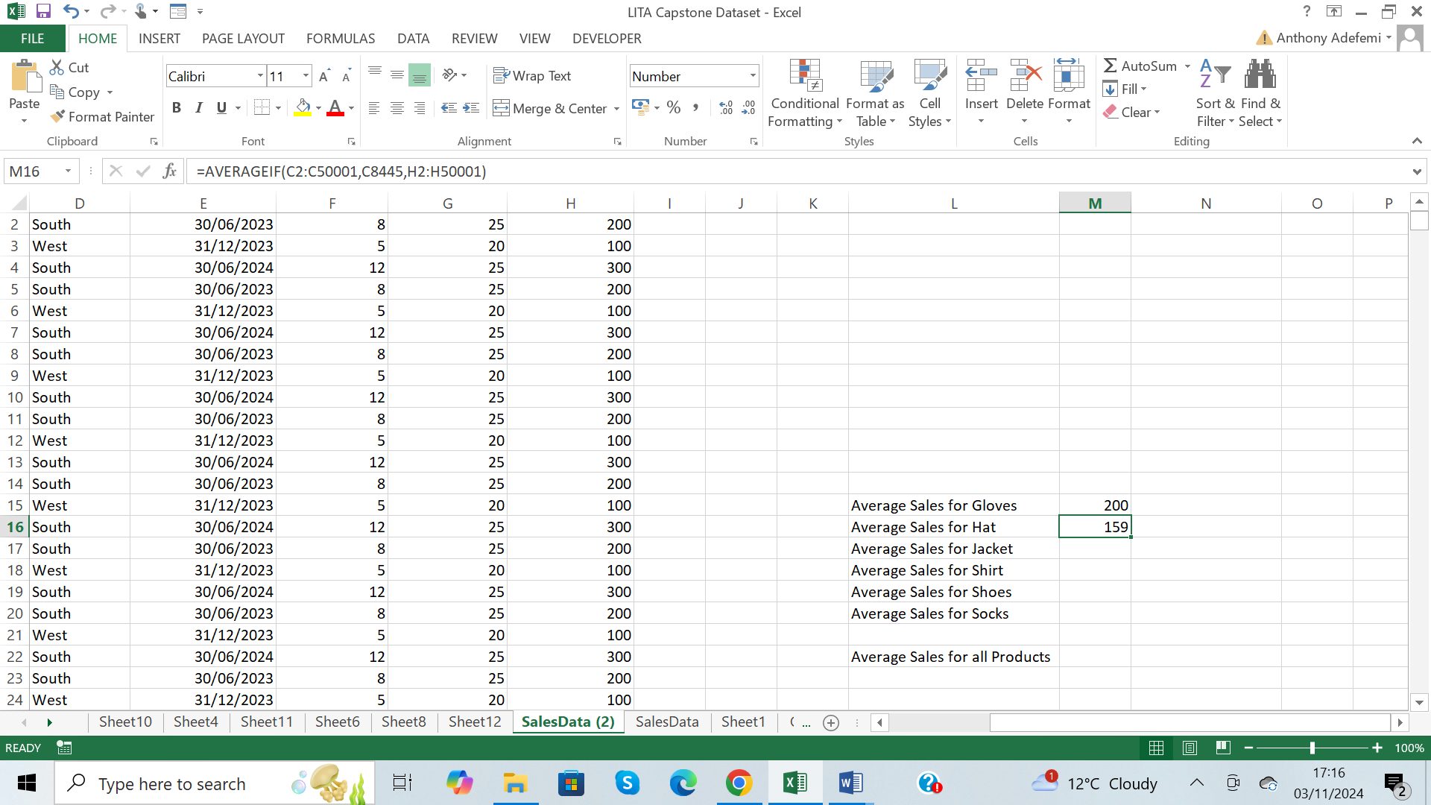

Average Sales for hat is 158.75, rounded up to a whole number is 159

Average Sales for Jacket

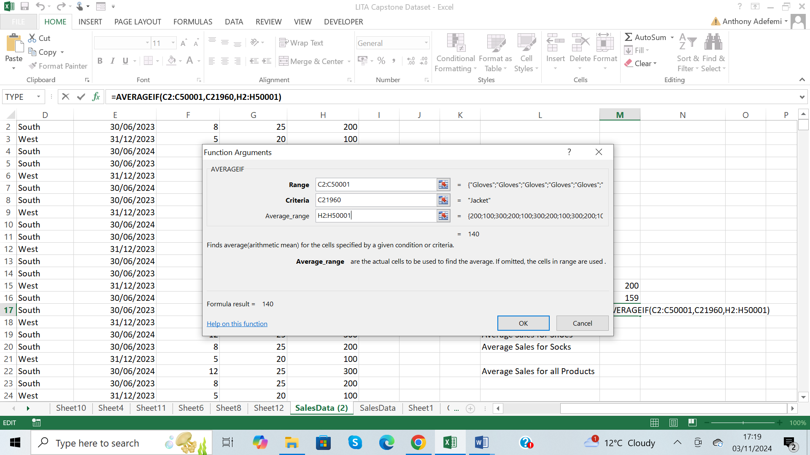

=AVERAGEIF then Ctrl A to open the function arguments dialogue box, enter the values, click ok

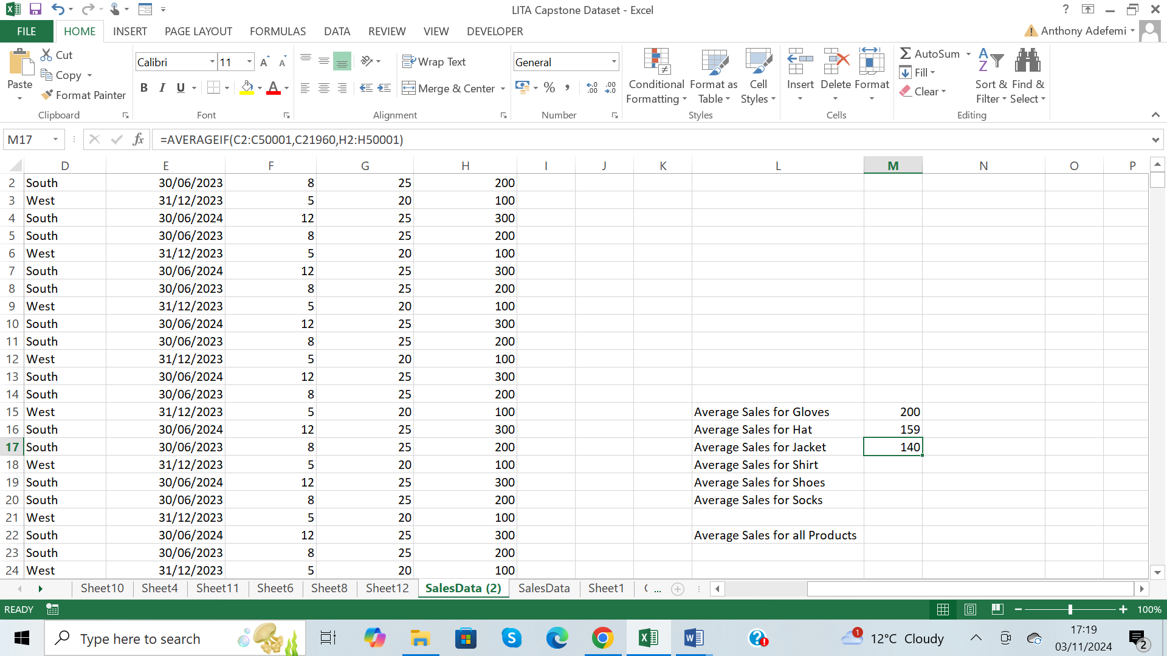

Average Sales for Jacket is 140

Average Sales for Shirt

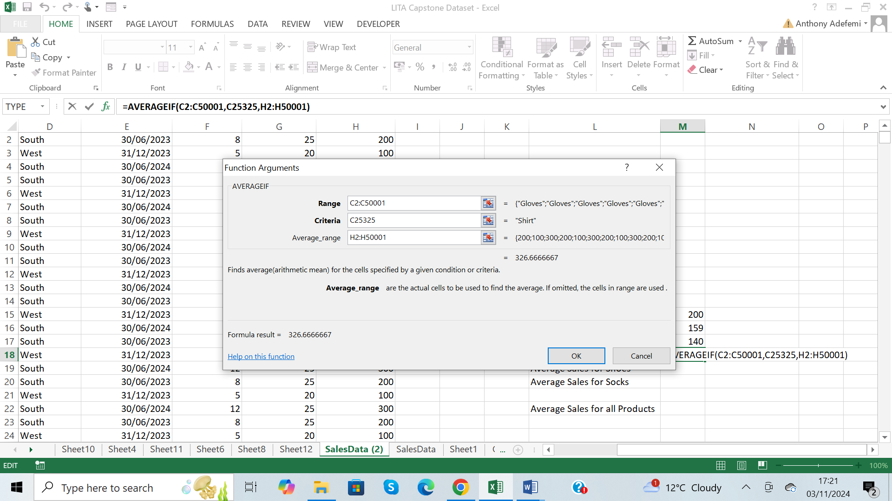

=AVERAGEIF then Ctrl A to open the function arguments dialogue box, enter the values, click ok

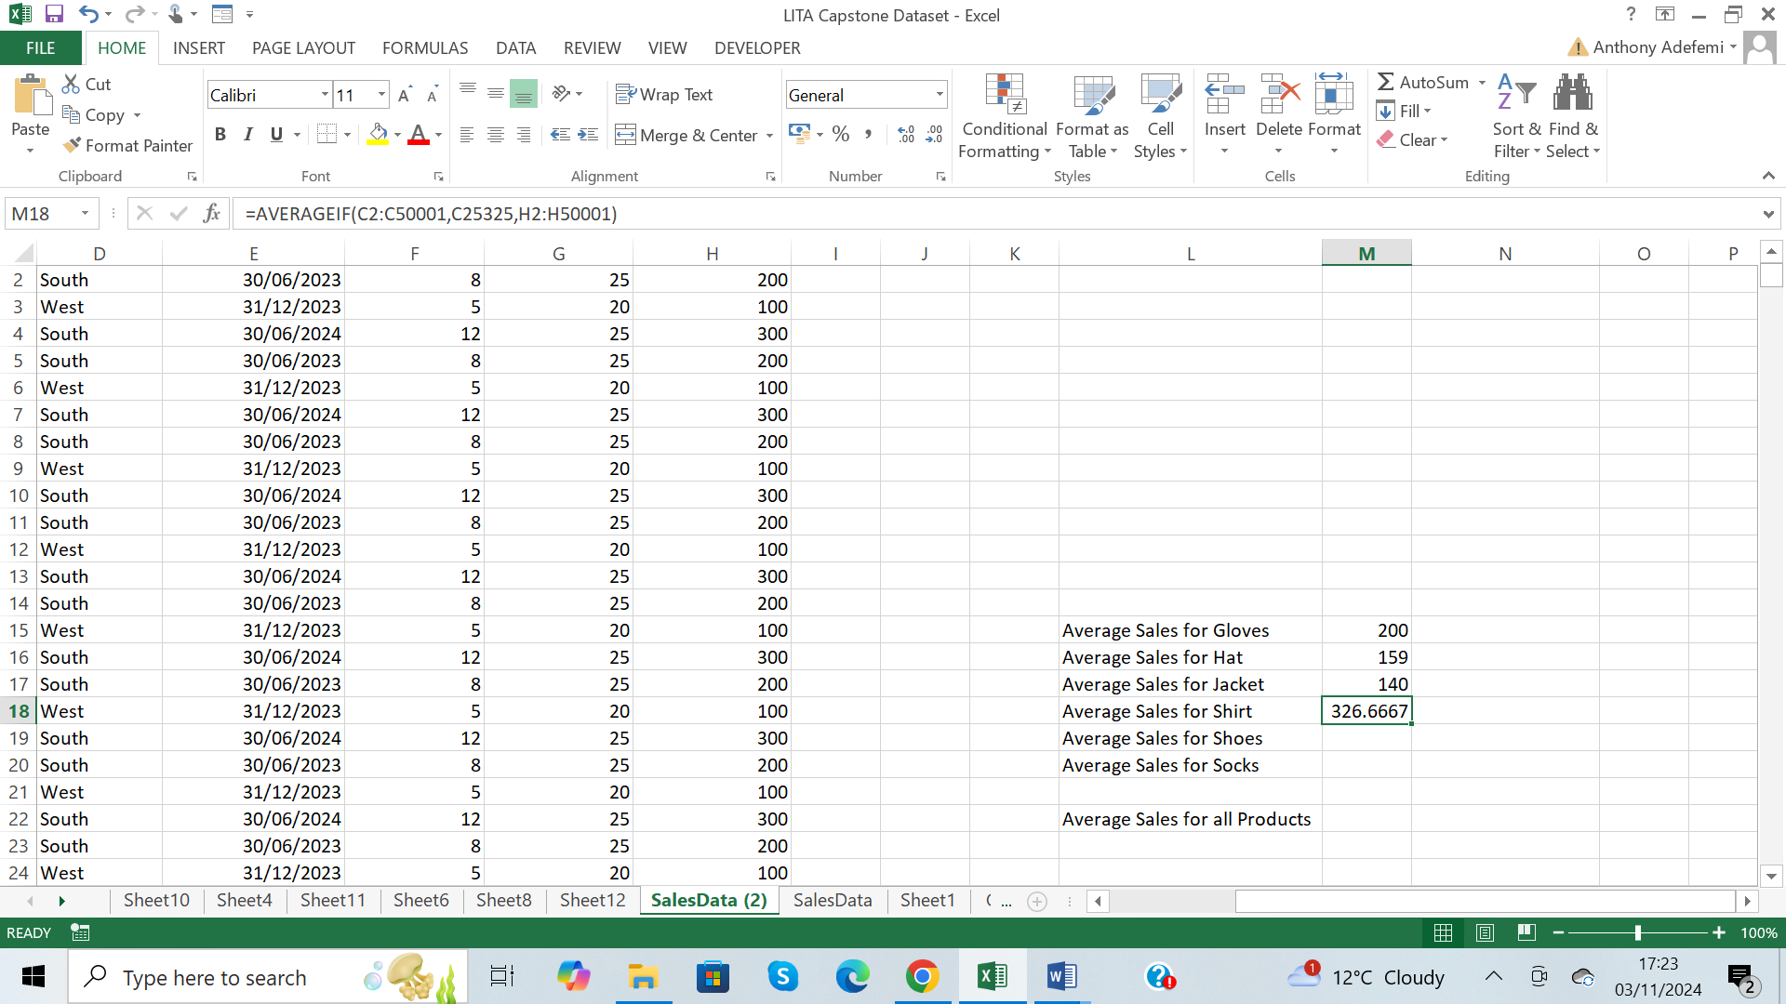

The Average Sales for shirt is 326.667

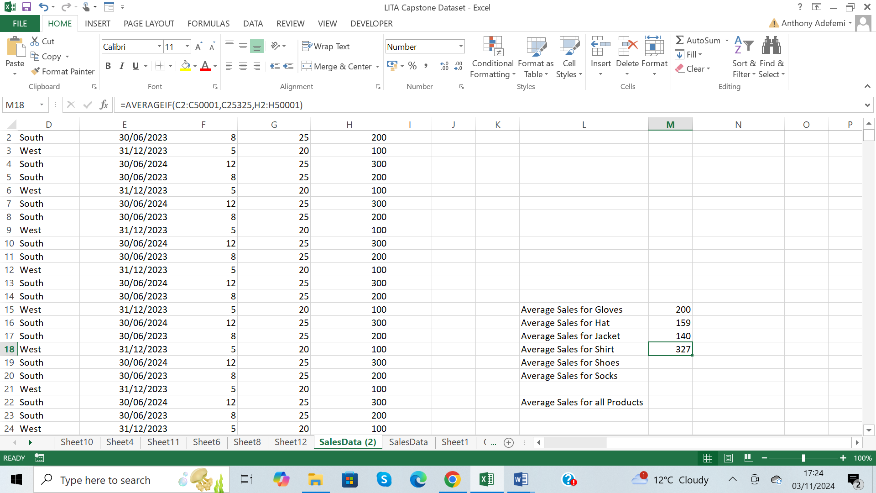

The Average Sales for shirt is 327 rounded up to the nearest whole number

Average Sales for shoes

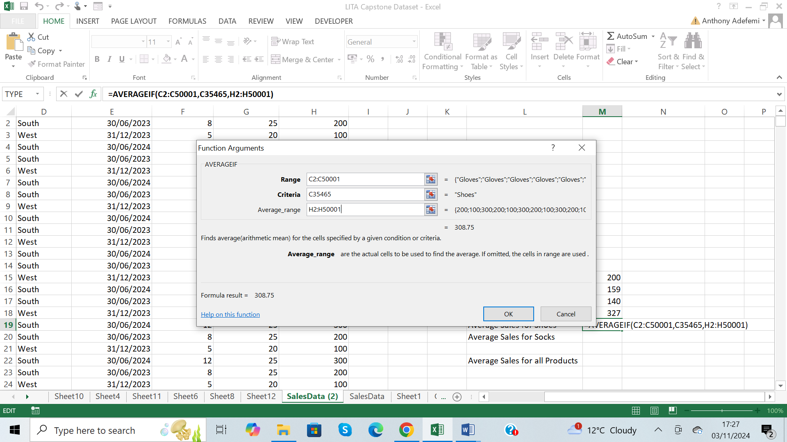

=AVERAGEIF then Ctrl A to open the function arguments dialogue box, enter the values, click ok

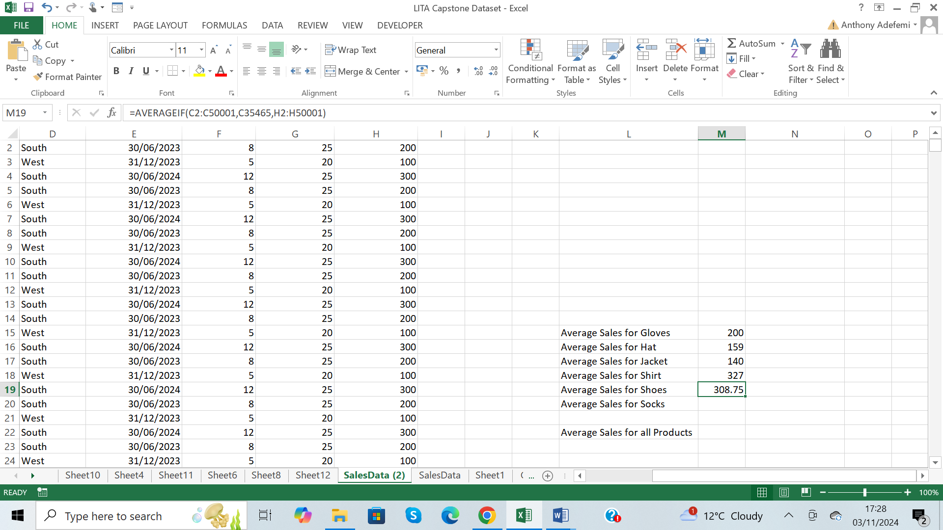

Average Sales for shoes is 308.75

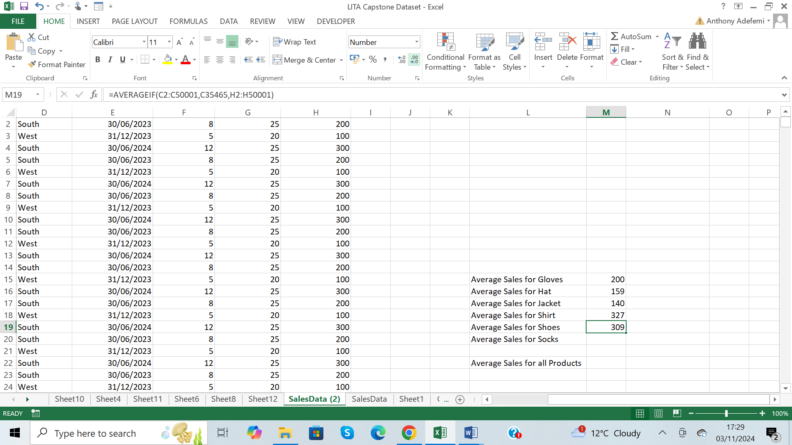

The average sales for shoes is 309 rounded up to the nearest whole number

Average Sales for socks

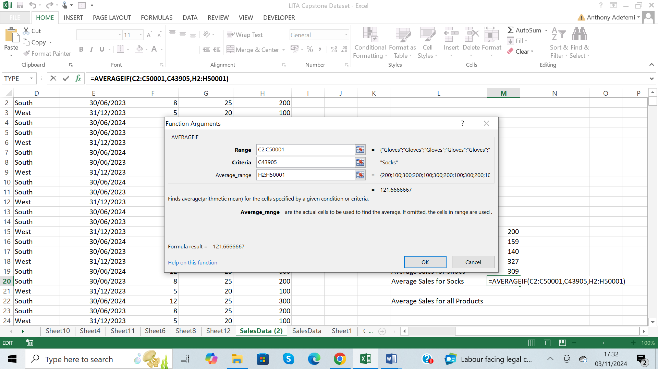

=AVERAGEIF then Ctrl A to open the function arguments dialogue box, enter the values, click ok

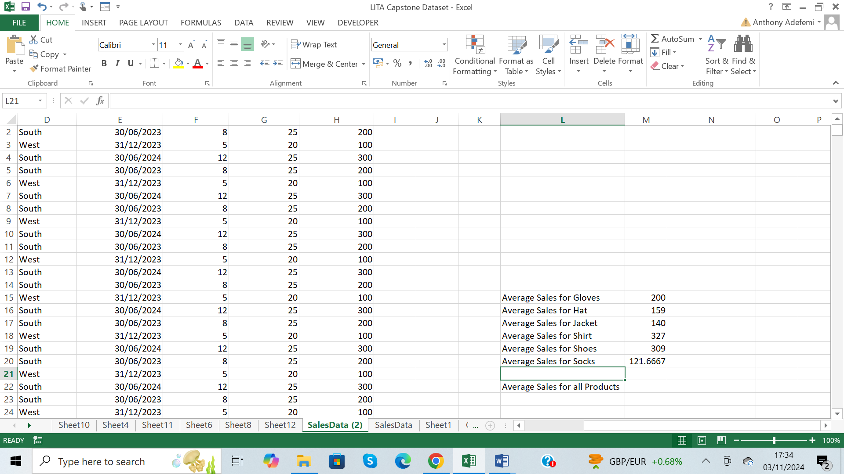

The average sales for socks is 121.6667

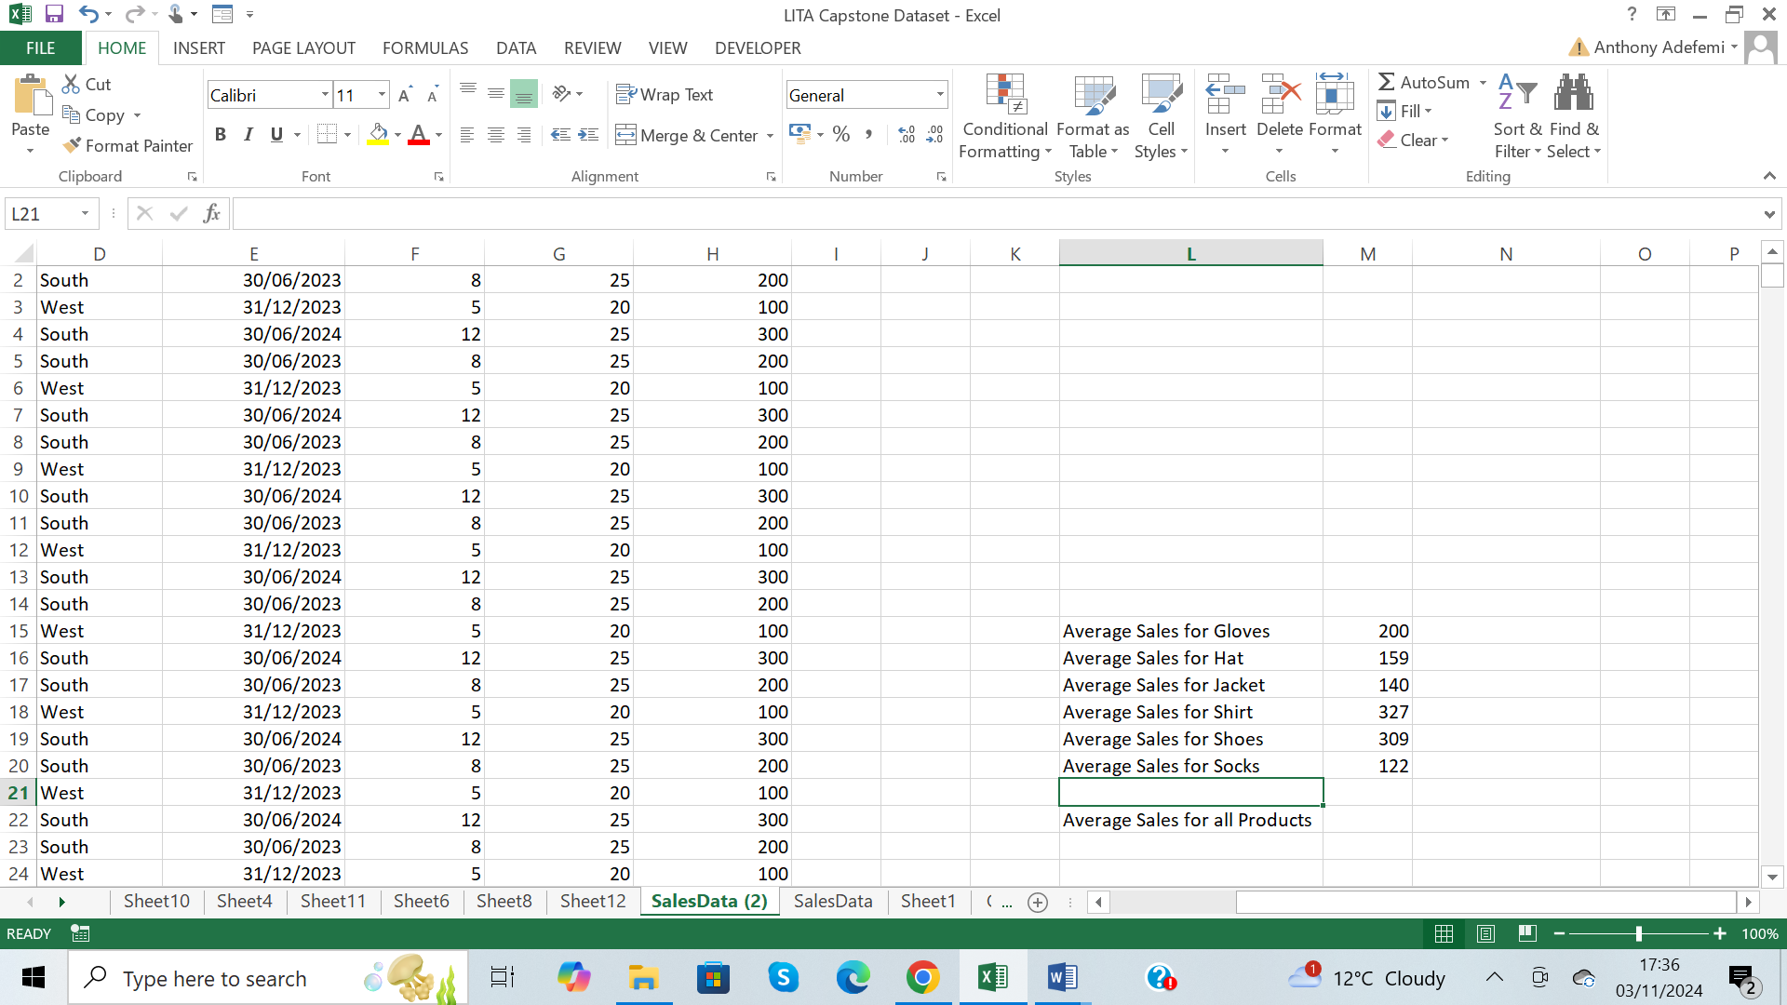

Average sales for socks rounded to a whole number is 122

Average Sales for all Products

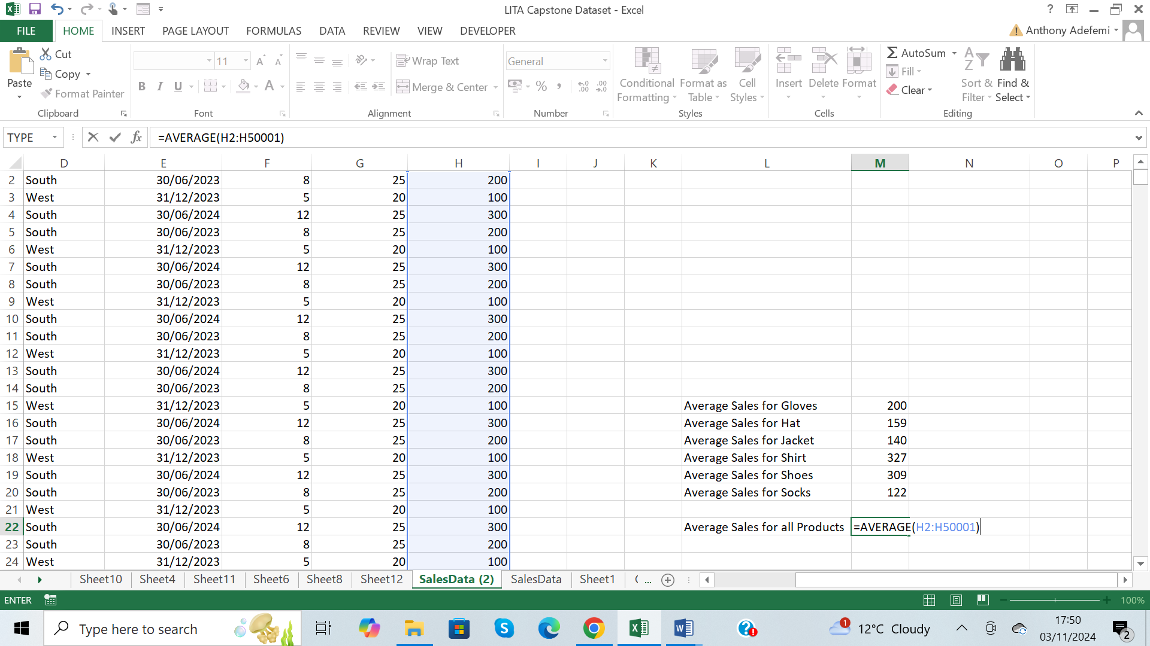

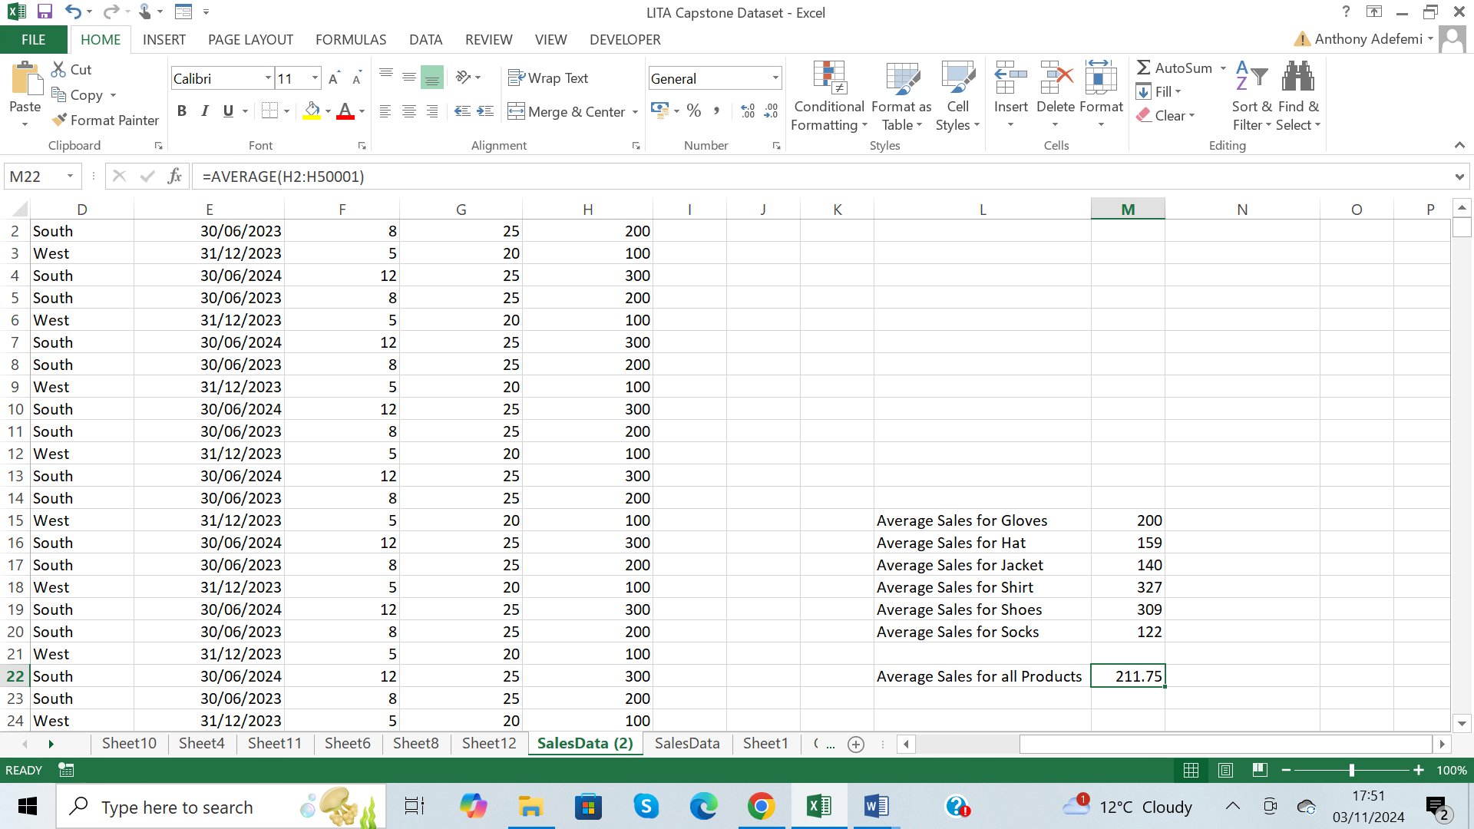

Average Sales for all Products is 211.75

Total Revenue by Region

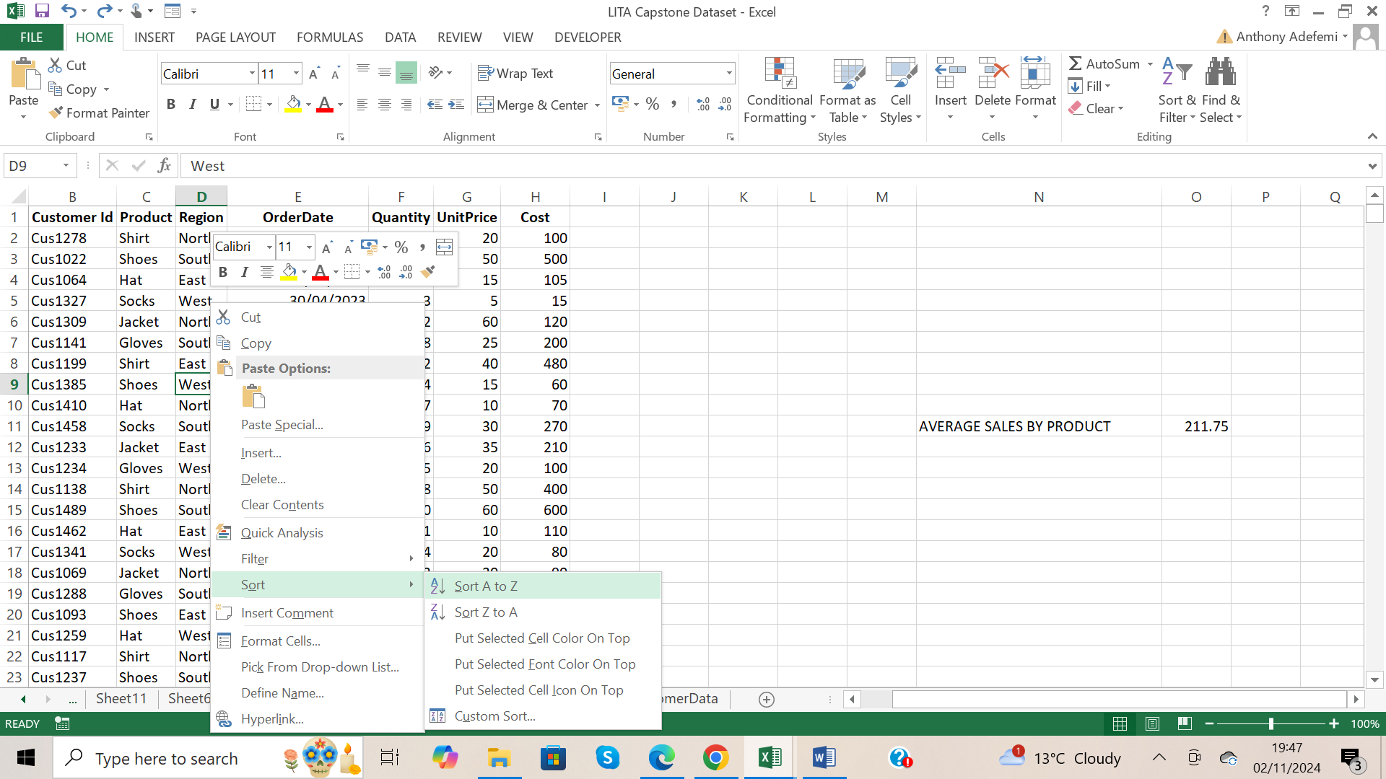

I sorted the Region column A to Z

East Region Total Sales

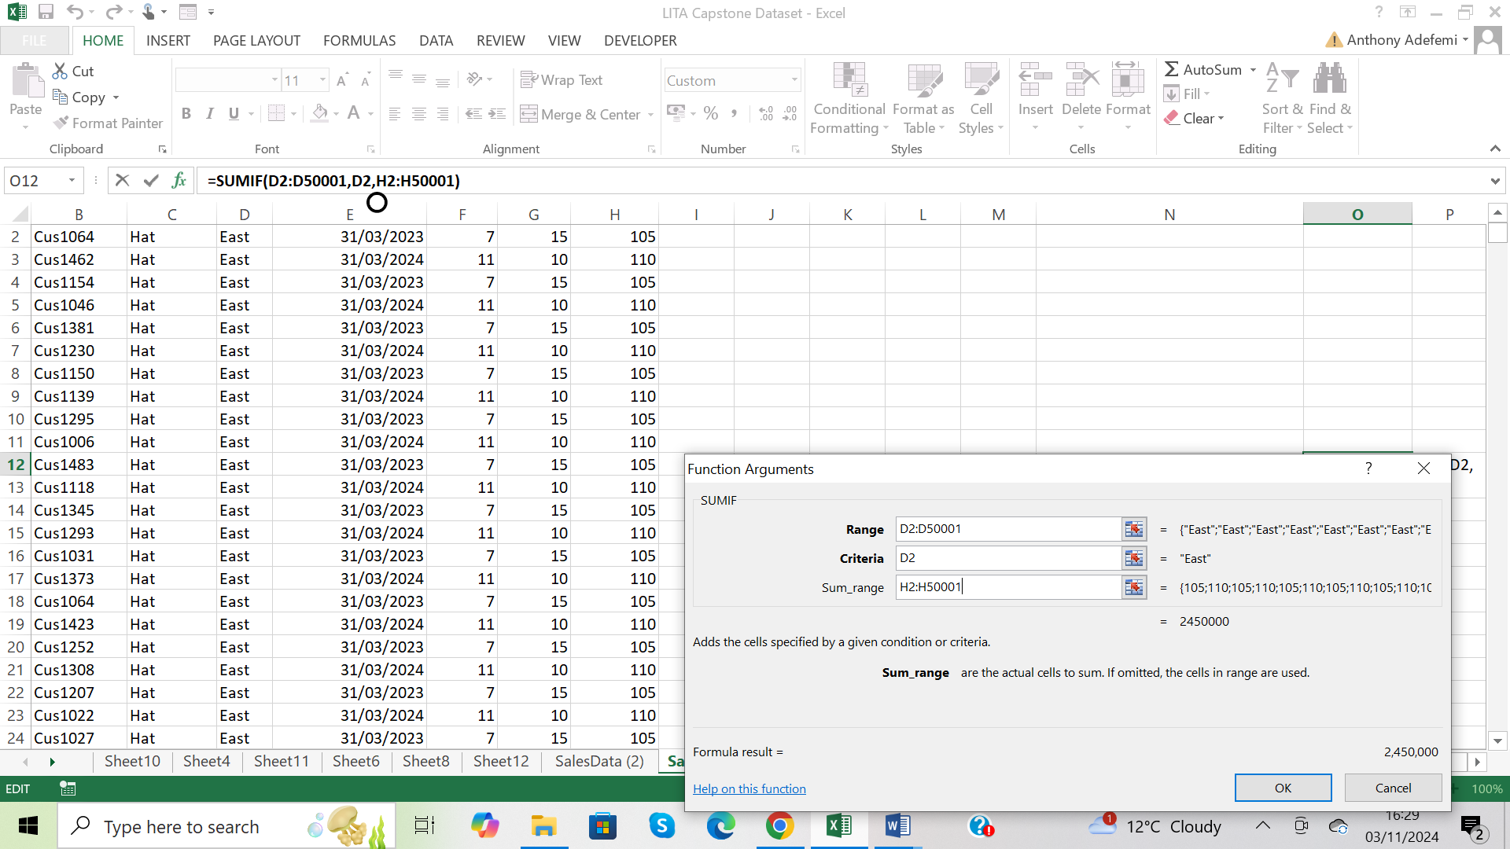

I sorted the Region Column A to Z

=SUMIF then Ctrl A to open the function arguments dialogue box, input data, click ok

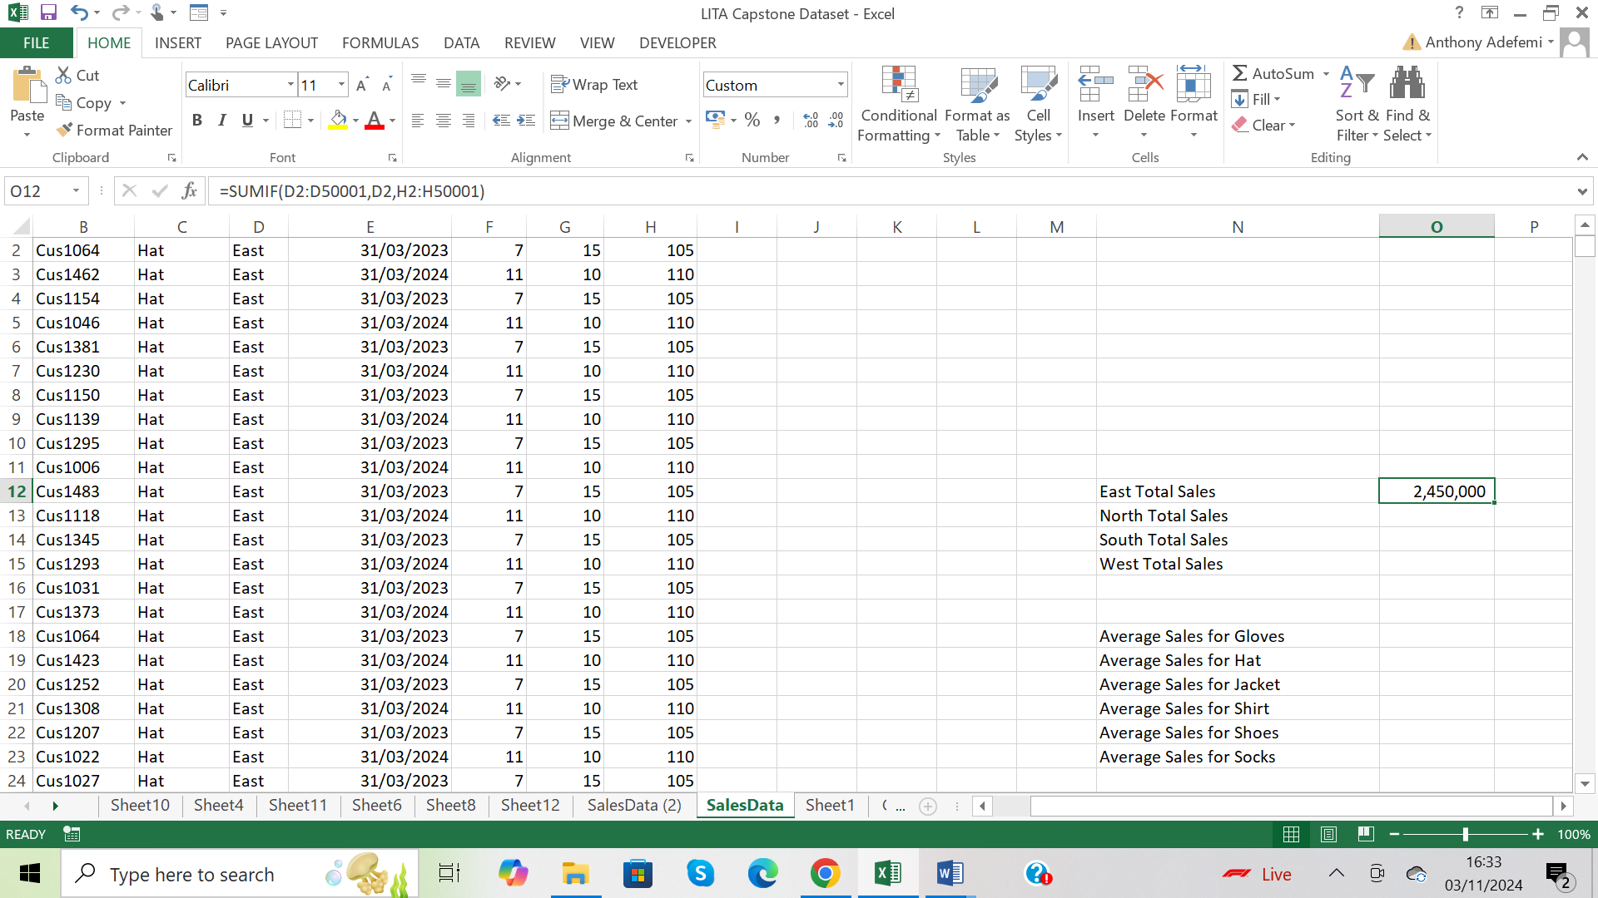

The Total Sales for East Region is 2,450,000

North Region Total Sales

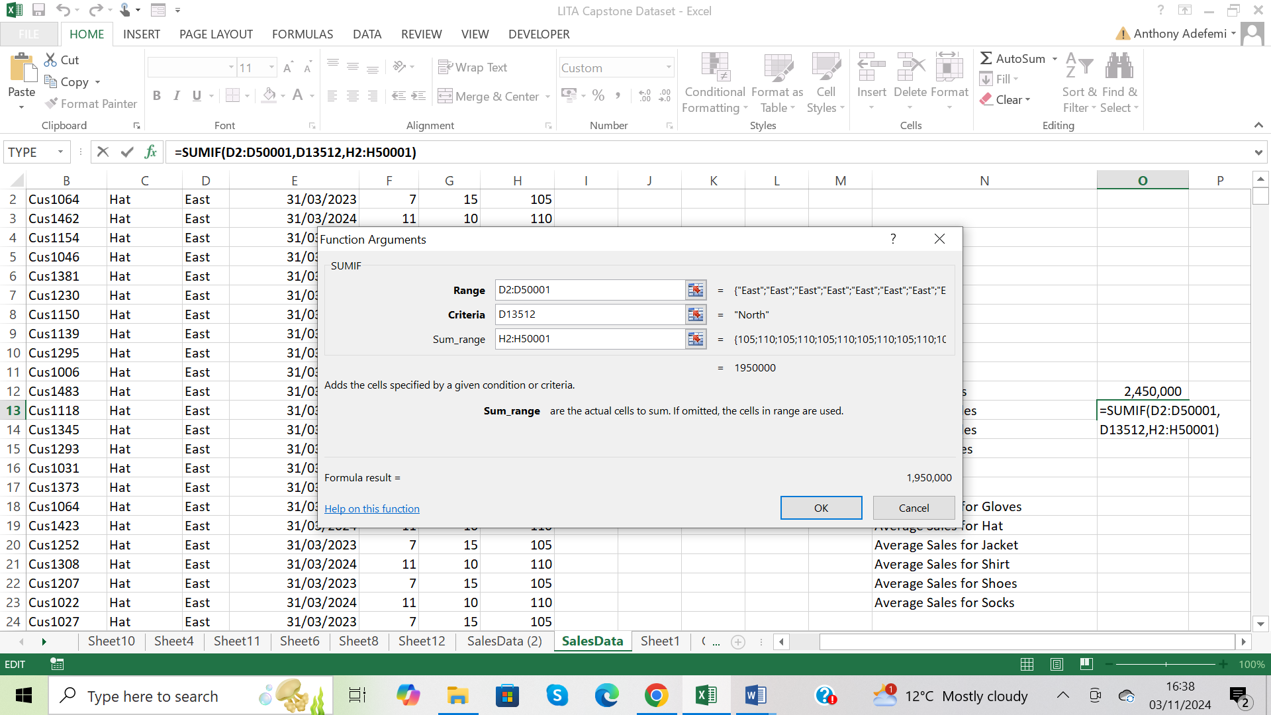

= SUMIF then Ctrl A to open the function arguments dialogue box, input data, click ok

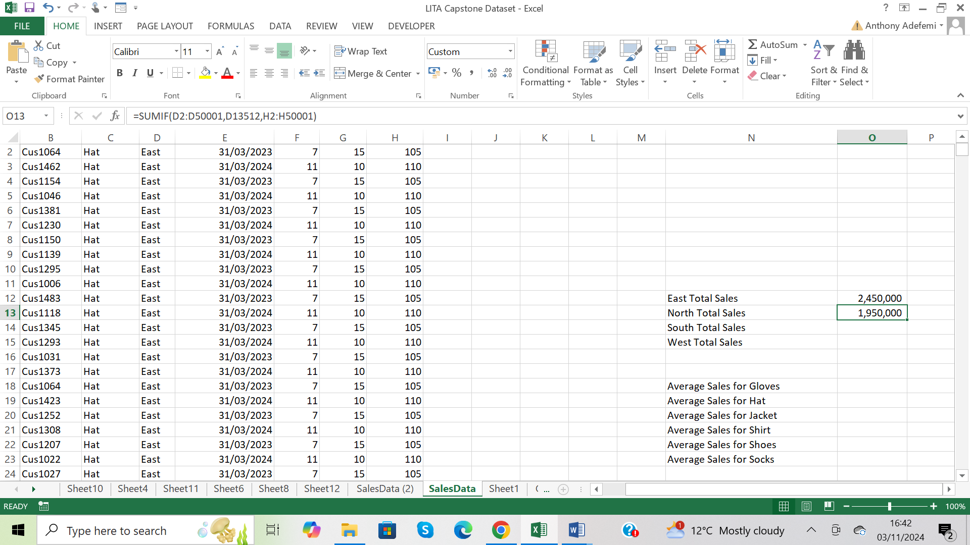

Total Sales for North Region is 1,950,000

South Region Total Sales

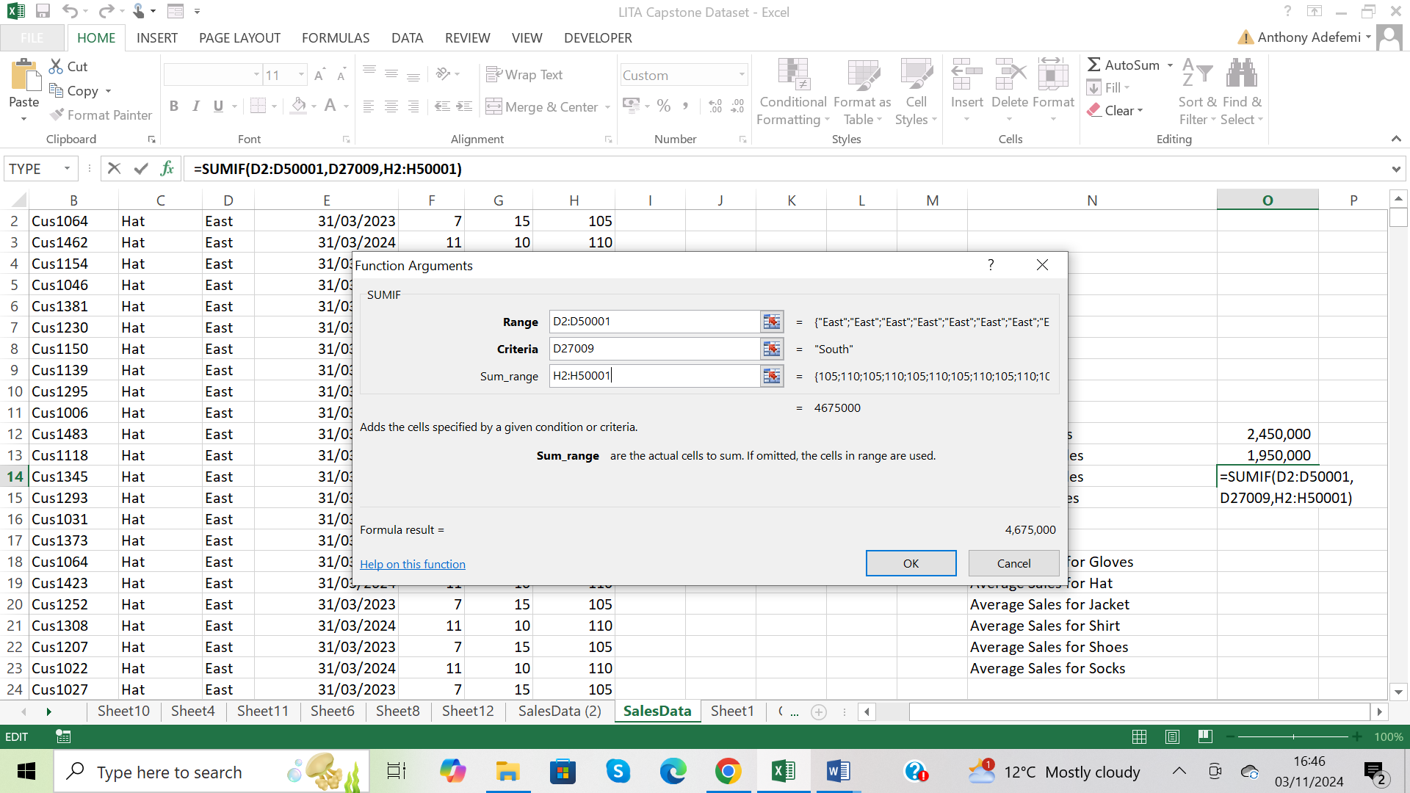

=SUMIF then Ctrl A to open the function arguments dialogue box, click ok

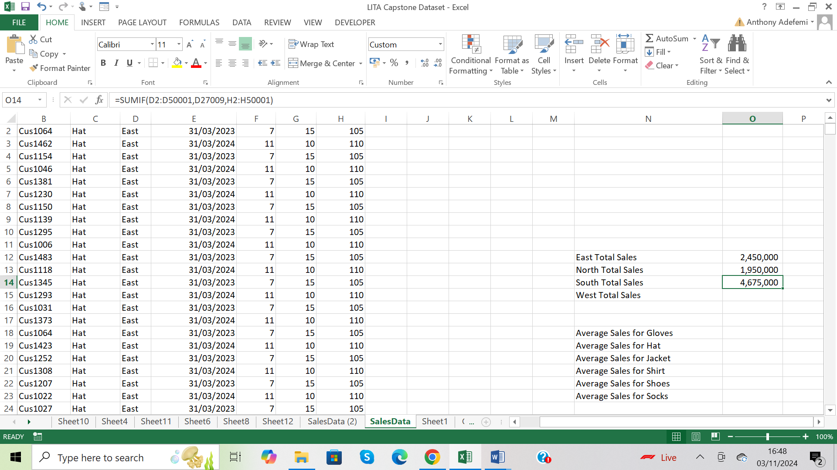

The South Region Total Sales is 4,675,000.

West Region Total Sales

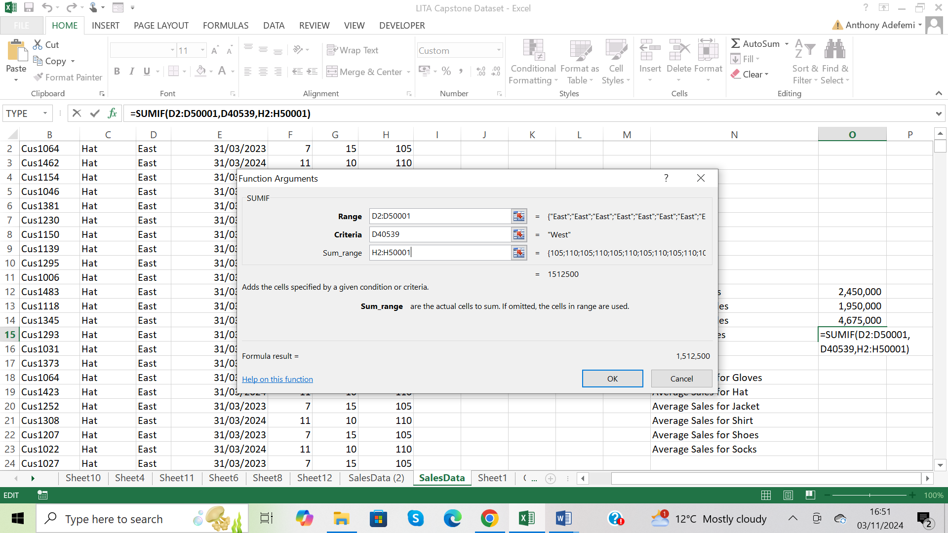

=SUMIF then Ctrl A to open the function arguments dialogue box, click ok

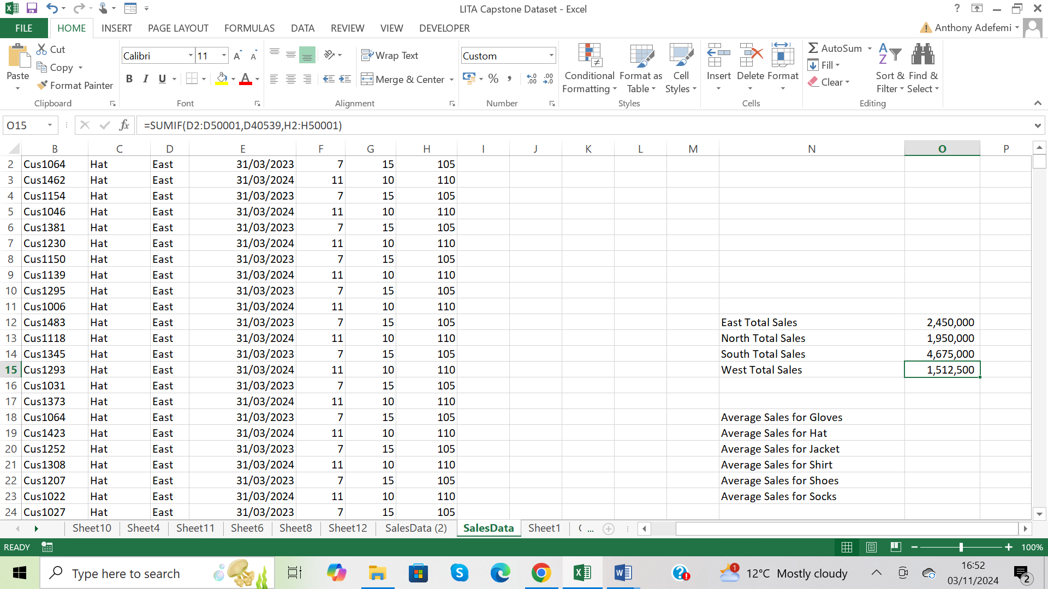

West Region Total Sales is 1,512,500

Pressed Alt +fn + f1 to display the chart

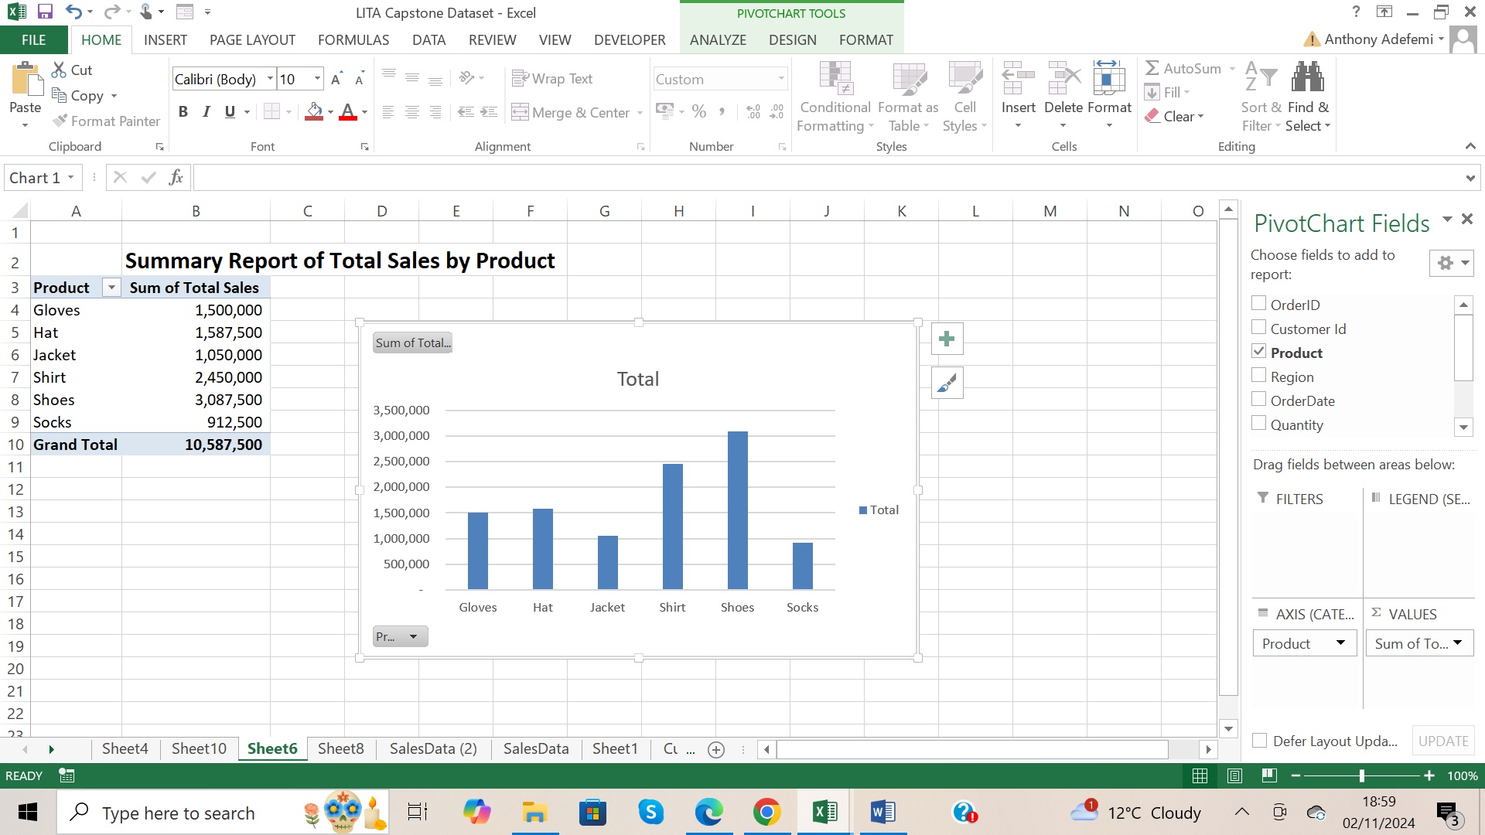

Ctrl + x to cut the chart, and pasted on a new worksheet

Renamed chart to Sum of Total Sales by Product

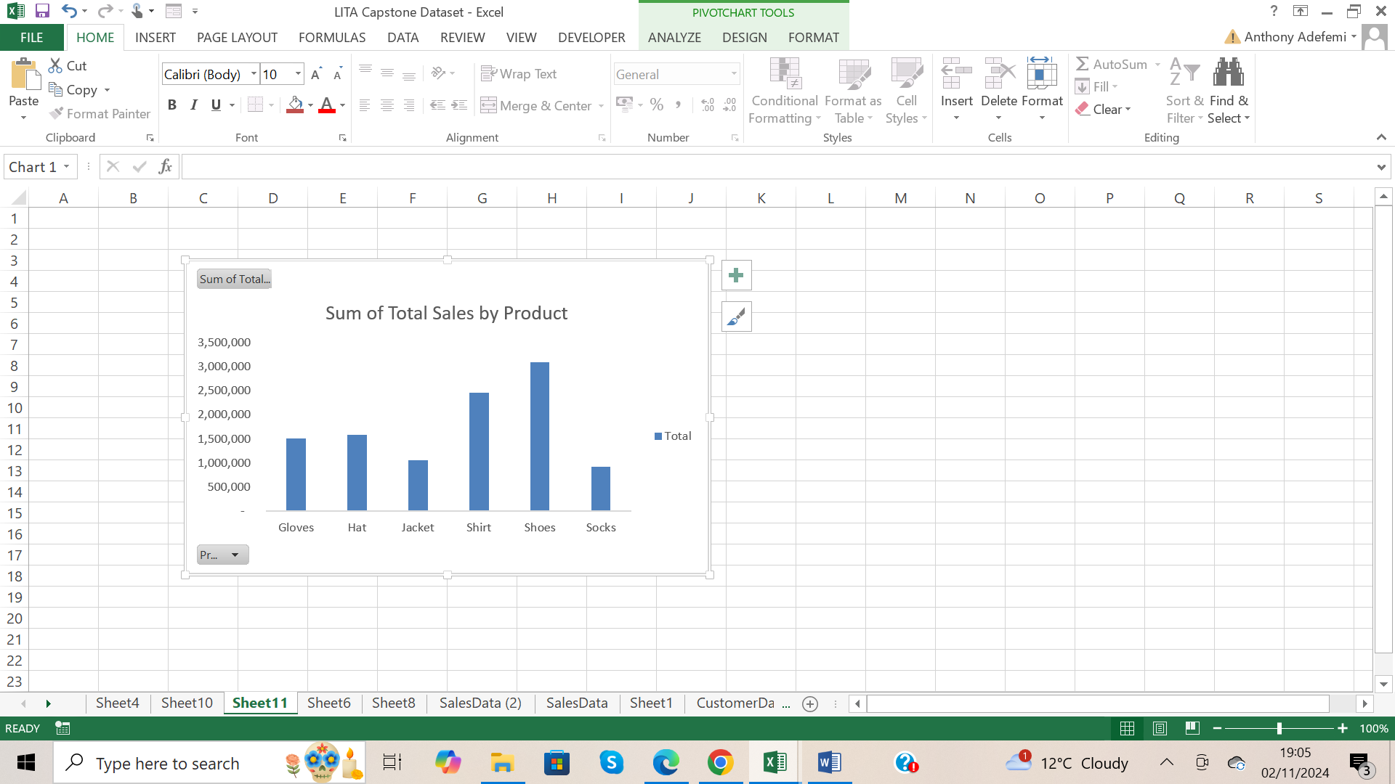

Deleted gridlines from the chart



From the chart the product with the highest number of total sales is shoes, product with the lowest number of total sales is socks.

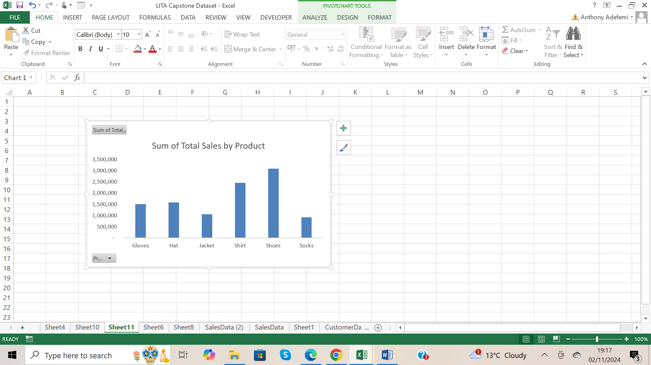

Deleted Legend Total

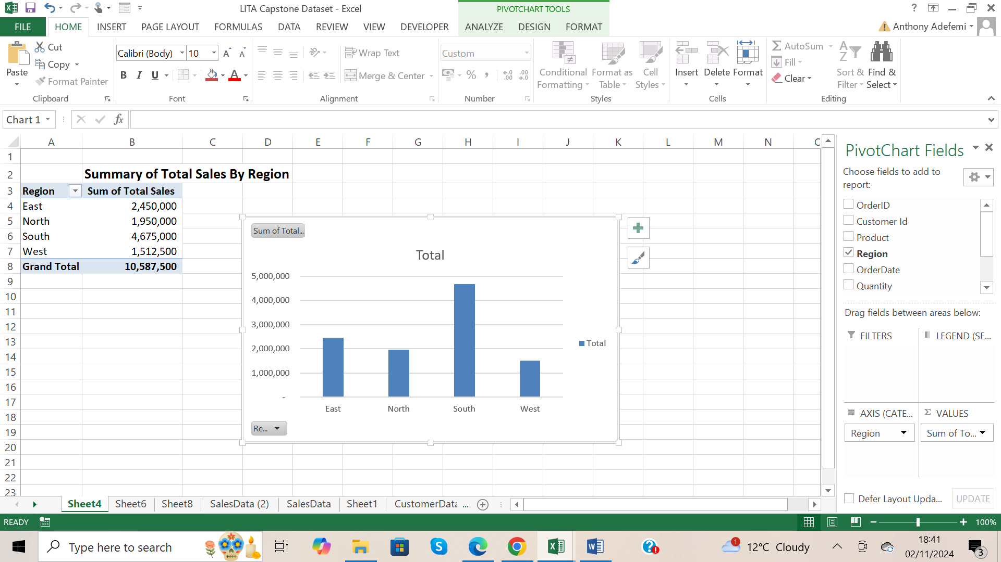

Pressed Alt +fn + f1 to display the chart

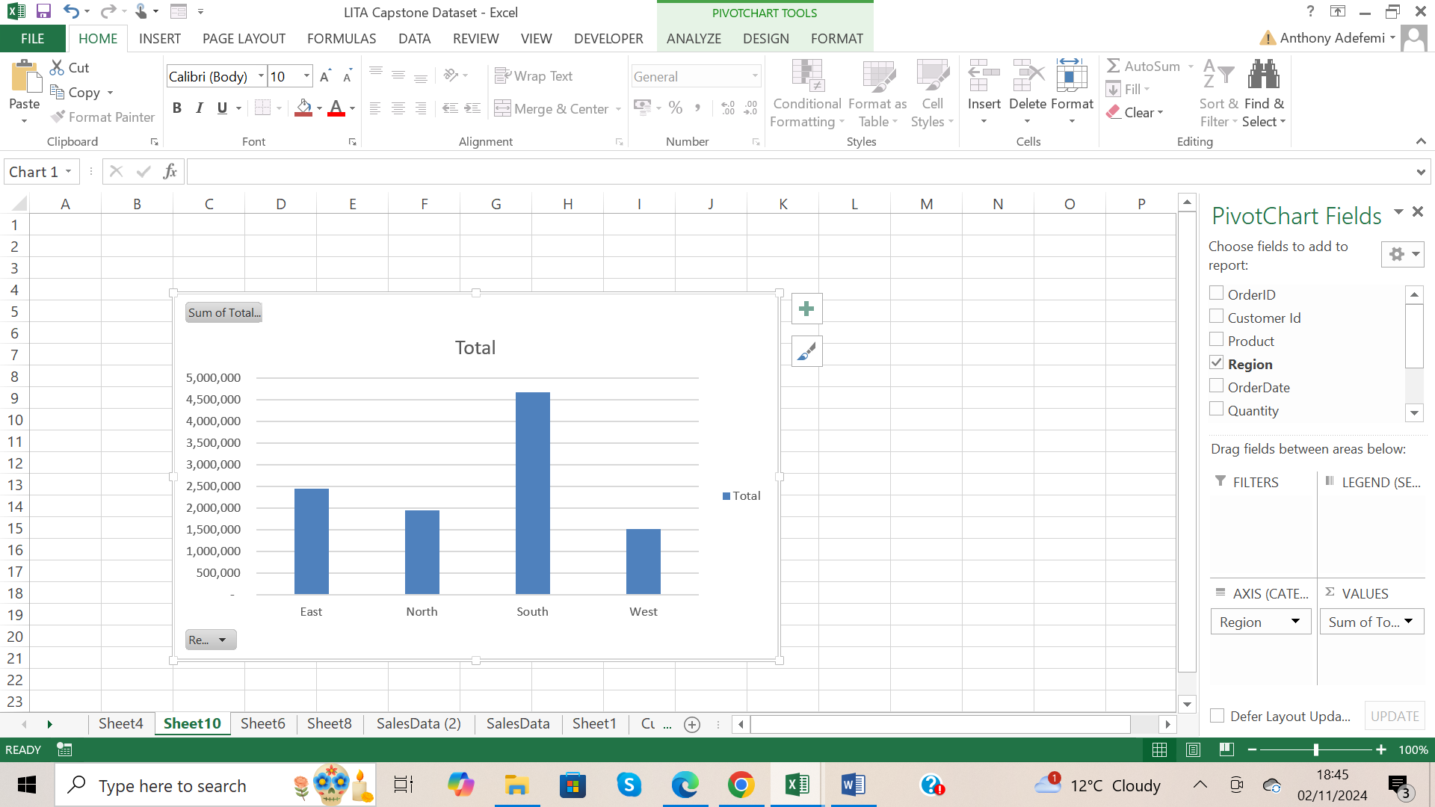  
Ctrl + x to cut the chart, and pasted on a new worksheet

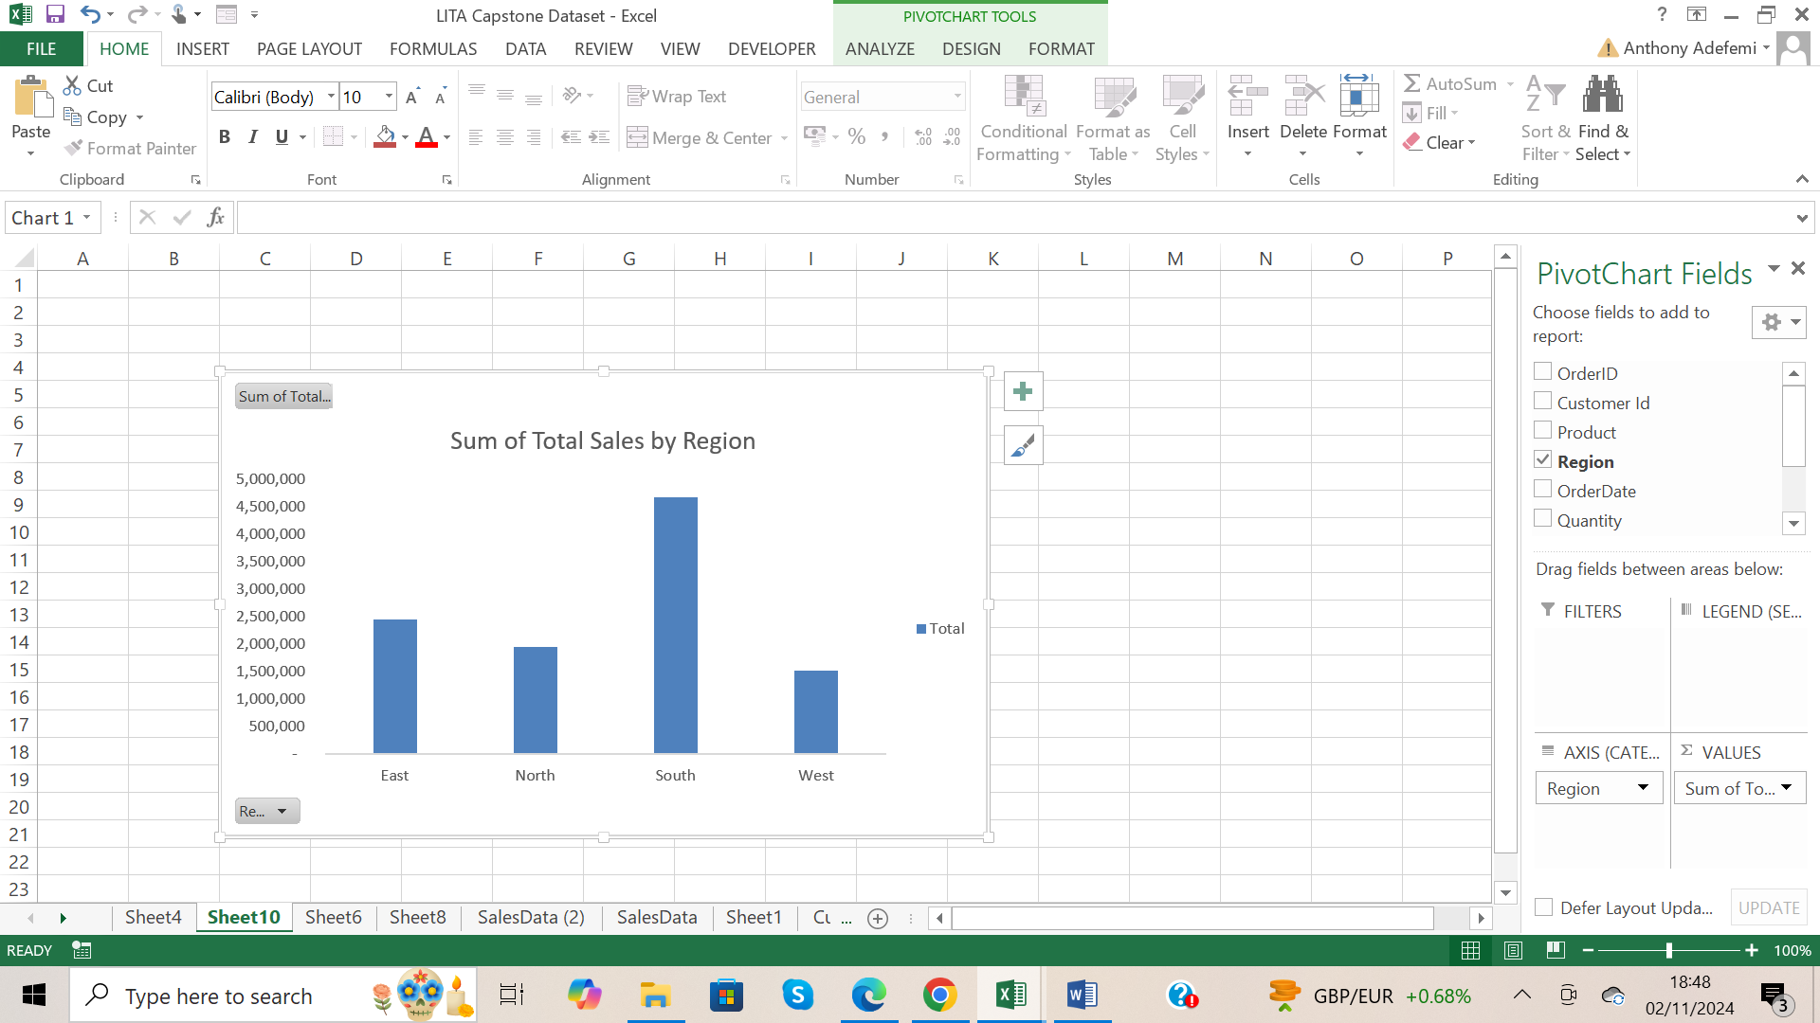

Renamed chart title to Sum of Total Sales by Region, and deleted gridlines.

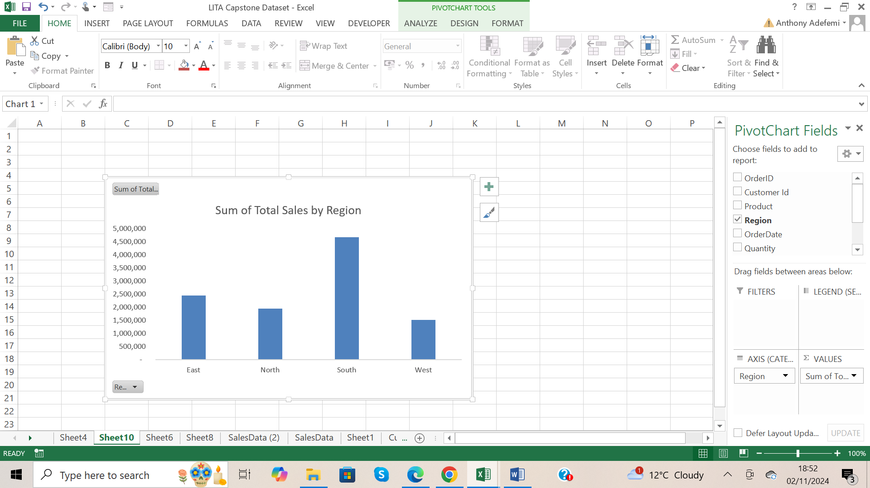

Deleted Legend(Total )

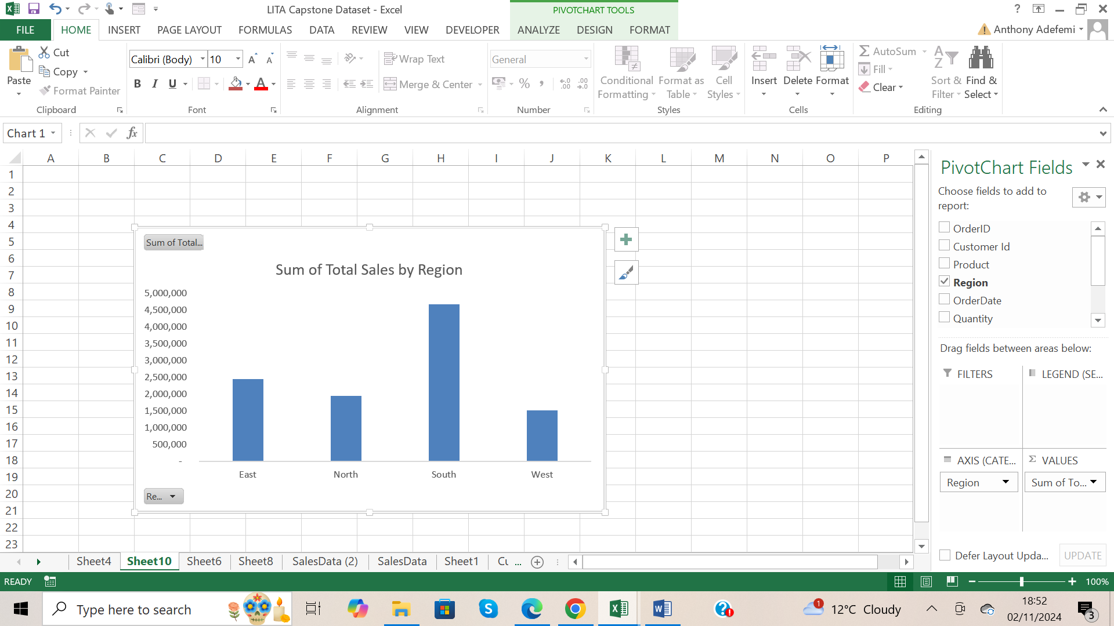

From the chart, South Region has the highest sum of total sales, West Region has the lowest sum of total sales.

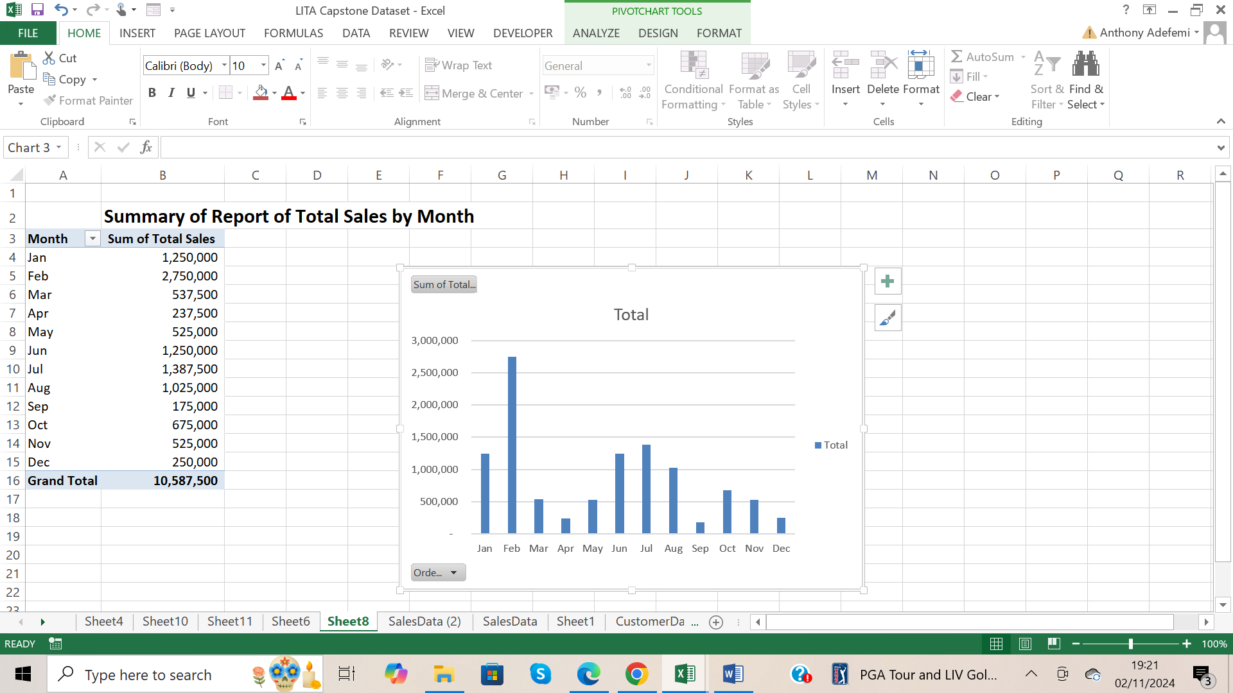

Pressed Alt +fn + f1 to display the chart

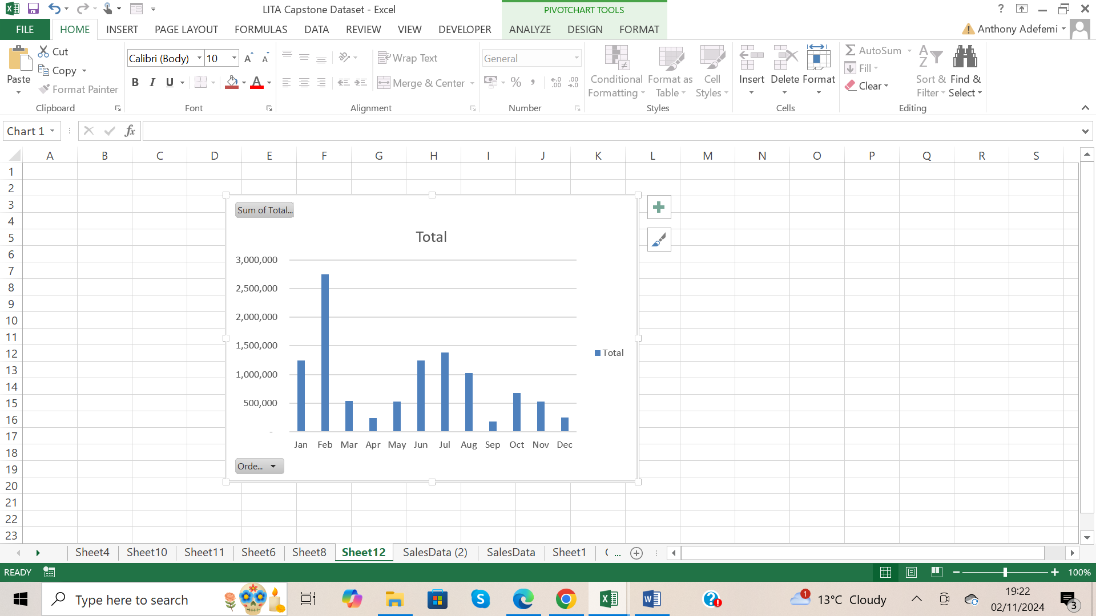

Ctrl + x to cut the chart, and pasted on a new worksheet

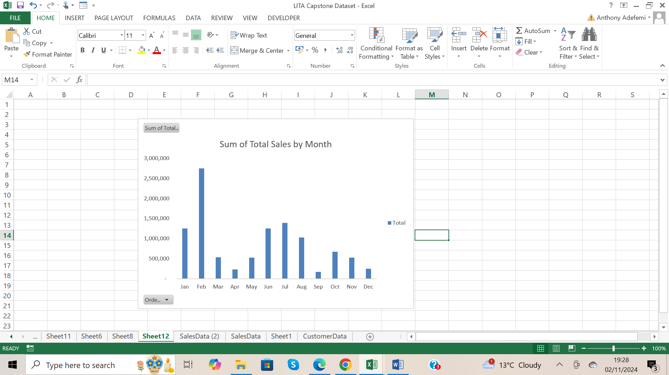

Renamed chart title to Sum of Total Sales by Month, and deleted gridlines.

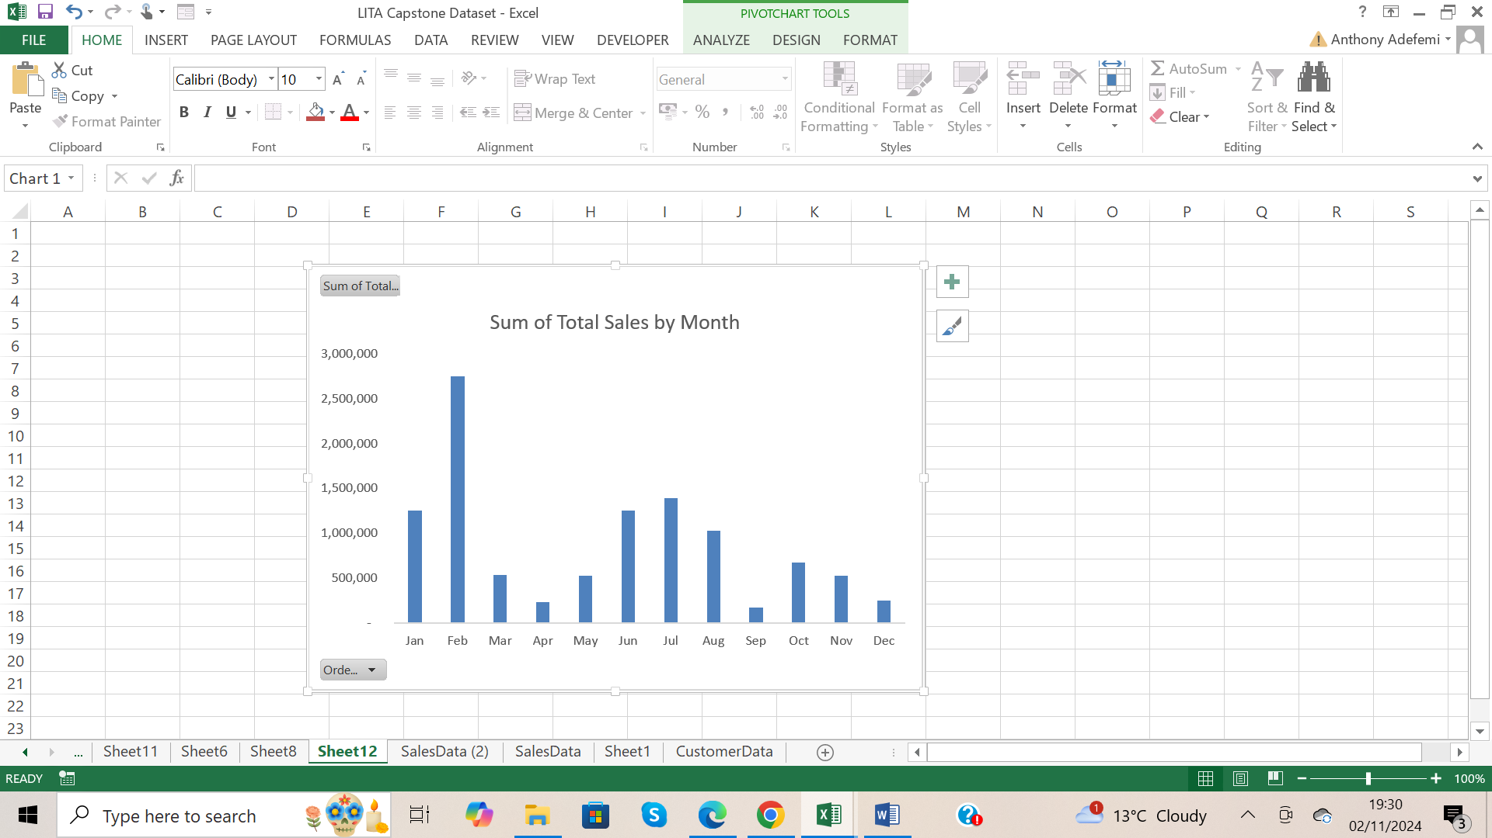

Deleted Legend(Total )



From the chart the highest sum of total sales was in February, and the lowest sum of total sales was in September.